

**Border Master**

**Border Crashers**

**Bo Yang 10123245**

**Ebtisam Alharbi 9620732**

**Prosper Irakoze 10240505**

**Zhijun Bai 10168646**

**Fu Yi 10151518**

**Minglu Li 10172292**

**Lingjie Zhang 10143735**

**Chengyu Wang 10193362**

**Ruben Enrique Padilla Robles 9962072**

**Table of contents**

List of figures……………………………………………………………………………….3

List of tables………………………………………………………………………………...4

Introduction………………………………………………………...……………………….5

Chapter 1 Responsibility

1.1 Background ……………………………………………………………………….........7

1.2 System actors’ roles and responsibilities …………………………………………...….7

1.3 Organizational C-level structure ………………………………………..……………..8

1.4 Responsibilities within Border Master’s departments………………………………….9

1.5 Leadership: Responsibility assignment matrix (RACI)……………………………….13

Chapter 2 Strategy

2.1 Background ……………………………………………………………………………14

2.2 System functionality…………………………………………………………………...14

2.2.1 Use case diagram………………………………………………………………….…14

2.2.2 Misuse case diagram…………………………………………………………………21

2.3 System process: Data flow diagram …………………………………………………...21

2.4 Risk Management ……………………………………………………………………...24

2.4.1 Risk management process…………………………………………………………....24

2.4.1.1 Risk modelling……………………………………………………………………..24

2.4.2 Standard risk assessment……………………………………………………………..25

2.4.2.1 Confidentiality, Integrity and Availability (CIA)……………………………….…25

2.4.2.2 Risk Assessment Codes (RACs)…………………………………………………...26

2.4.3 Risk decision…………………………………………………………………………27

2.4.4 Risk mitigation and treatment plan…………………………………………………..28

2.5 Border Master cybersecurity …………………………………………………………..32

2.5.1 Cybersecurity goals ………………………………………………………………….32

2.5.2 Information security management ………………………………………………….. 32

2.5.3 Network security………………………………………………………………….….32

2.5.3.1 PDR model…………………………………………………………………...…..32

2.5.3.2 PPDRR model……………………………………………………………………33

2.5.4 Authentication and authorization………………………………………………..…33

2.5.5 Human resources security……………………………………………………...…..34

2.5.6 Physical and environmental security……………………………………………....34

2.5.7 Security architecture……………………………………………………………….36

Chapter 3 Acquisition

3.1 Background …………………………………………………………………………..37

3.2 Project plan …………………………………………………………………………..37

3.2.1 Project scope ……………………………………………………………………….37

3.2.2 Requirements ………………………………………………………………………37

3.2.3 Project schedule ……………………………………………………………………38

* + 1. Gantt chart………………………………………………………………………..42
  1. Suppliers management.……………………………………………………………..43
     1. Sourcing strategy………………………………………………………………...44
     2. Supplier selection ……………………………………………………………….45
     3. Relationship management……………………………………………………….45
  2. Total Cost of Ownership (TCO)…………………………………………………...46

Chapter 4 Performance

4.1 Background………………………………………………………………………….49

4.2 Desired performance, evaluation and improvement………………………………...49

* + 1. Response time……………………………………………………………….…..49
    2. Maximum concurrency………………………………………………………….50
    3. Cyber security…………………………………………………………………...51
    4. Confidentiality……………………………………………………………..…....52

4.3 Determine IT goals……………………………………………………………..........53

4.4 Security performance measures …………………………………………………….54

4.4.1 The Balanced Scorecard ………………………………………………………….55

4.4.2 Measurement of Customer Performance…………………………………………55

4.4.3 Measurement of Improvement Performance………………………………………61

4.4.4 Measurement of Operational Performance……………………………………66

4.4.5 Measurement of Financial and risk management Performance……………….71

Chapter 5 Conformance

5.1 Background………………………………………………………………………75

5.2 Security policy……………………………………………………………………75

* + 1. ISO/IEC 27001……………………………………………………………….75
    2. Payment Card Industry Data Security Standard (PCI DSS) …………………88
  1. Regulation laws and business operations governance…………………………....101
     1. Regulations and Acts…………………………………………………………101
     2. ISO/IEC 27001……………………………………………………………….103
     3. ISO/IEC 27002……………………………………………………………….103
     4. ISO/IEC 27007…………………………………………………………….…103
     5. Intellectual property rights …………………………………………………..104

Chapter 6 Human Behaviour

6.1 Background…………………………………………………………………….....105

6.2 Human Error Assessment & Reduction Technique (HEART)……………...…...105

6.2.1 Human Motivations ……………………………………………………………106

6.2.3 Assessment of human errors…………………………………………………....108

6.2.4 Human errors’ mitigation and treatment plan………………………………….109

6.3 Human cantered design…………………………………………………………..110

* + 1. Cybersecurity usability……………………………………………………….110

6.3.2 Testing users……………………………………………………………………112

Conclusion …………………………………………………………………..…….…113

References………………………………………………………………………...…..114

**List of figures**

Figure 1 C-level structure…………………………………………………………………..8

Figure 2 The use case diagram…………………………………………………………….15

Figure 3 The misuse case diagram……………………………………………………........21

Figure 4 The data flow diagram……………………………………………………………22

Figure 5 The processes of risk management…………………………………………….....24

Figure 6 The risk decision…………………………………………………………...……..27

Figure 7 The stakeholder analysis model………………………………………………..…28

Figure 8 The PDR model………………………………………………………………..….32

Figure 9 The PPDRR model………………………………………………………….…….33

Figure 10 The Border Master security architecture…………………………………….…..36

Figure 11Supplier characteristics………………………………………………………..…40

Figure 12 The System Development Life Cycle(SDLC)……………………………….….41

Figure 13 The project plan…………………………………………………………...…….42

Figure 14 The procedure for vendor orientation…………………………………………...43

Figure 15 The components of TCO……………………………………………………….. 47

Figure 16 The dashboard of Customer performance…………………………………….…61

Figure 17 The dashboard of improvement performance…………………………………. .65

Figure 18 The dashboard of operational performance……………………………………..70

Figure 19 The dashboard of Financial and risk performance………………………..….....74

Figure 20 The risk components……………………………………………………………105

Figure 21 The motivation of human errors………………………………………………..106

Figure 22 The components of usability………………………………………………….. .110

Figure 23 The usability test ………………………………………………………………111

**List of tables**

Table 1 The responsibilities within Border Master’s departments……………………………9

Table 2 The RACI matrix…………………………………………………………………….13

Table 3 The CIA assessment model………………………………………………………….25

Table 4 The risk matrix…………………………………………………………………........26

Table 5 The RAC model…………………………………………………………………..…26

Table 6 The Sourcing strategy’s checklist of suppliers………………………………………43

Table 7 The supplier selection of the Border Master……………………………………...…44

Table 8 The total cost of ownership (TCO)…………………………………………….……48

Table 9 The IT goals…………………………………………………………………………53

Table 10 The scoreboard of Customer………………………..……………………………..56

Table 11 The scoreboard of Implementation………………………………………………..62

Table 12 The scoreboard of operations …………………..……………………………...….67

Table 13 The scoreboard of Financial and risk management………………………………..71

Table 14 The motivation matrix………………………………………………………….…107

Table 15 The human factors risk……………………………………………………………108

Table 16 The testing result……………………………………………………..……….…..112

**Introduction**

In the new global economy, IT governance has become essential for any business project to achieve its objectives. IT governance is a framework to ensure running the system smoothly to meet the business’s mission. This paper reports on a study which is building the Border Master information security system based on the six principles of IT governance which are identified in ISO/IEC 38500.

The overall structure of the project takes the form of six chapters, Chapter One identifies Responsibilities and accountabilities for different roles to meet system’s objectives. Chapter Two begins by laying out the strategic security to ensure the security of the system. Chapter three identifies the acquisition plan which includes the time line of the project and total cost of ownership. Chapter four focuses on measurements of the performance of IT system using the balanced scoreboard and the dashboard. Chapter five explains the standers of the IT Governance and the importance of using them in Border Mater system. Finally, chapter six examine the human behavior as an essential element during building information systems, considering the human motivations and asses their risks to enhance their productivity and improve the overall performance.

**Chapter 1 Responsibility**

* 1. **Background**

Responsibility is the first principle of IT Governance that each member in the organization has a role. Overall approaches towards the impactful corporate governance indicate that each organization and institution should determine and clarify procedures to be adopted to govern and manage information, information resources and most importantly the information technologies on which its policies, business model, targets and strategies rely.

A structure of an organization should demonstrate a framework for its leadership model, responsibilities, business processes, standards and compliance to these standards, which ensure that the organization’s information systems support the achievement of targets vis-à-vis the organization’s objectives and strategies.

Successful implementation of the Border Master System depends on clearly defined structures and responsibilities which are strategically assigned to all actors to ensure they actively and properly play their roles. In the following parts of this chapter the actors in the Border Master system and their responsibilities will be explained in depth to clarify the dynamisms within system.

**1.2 System actors’ roles and responsibilities**

Border Master actors should use the system with clearly and well-defined responsibilities, so they can meet core objectives of the organization. The actors should be classified into different hierarchical categories considering the nature of their work. The categories of actors should include top managers and directors of units.

Top managers, under the leadership of the Chief Executive Officer (CEO), constitute the higher decision-making for the Border Master system. CEO oversees and manages businesses with a high-level guidance to meet the business objectives. Most importantly, the decision maker focuses on policy management level to make simple, comprehensive and strategic plans to achieve business objectives.

Duties of directors of units should consist of acting as liaison between top managers and technical teams. They should continuously coordinate, monitor and evaluate activities of all departments, including financial, audit, legal and most importantly IT processes. Furthermore, they should produce analysis and reports to the top manager for decision making purposes.

**1.3 Organizational C-level structure**

The C-level structure describes executive positions within the organization that manages the Border Master system. The structure is envisioned to be an appropriate strategic group to support the system’s operations to achieve productivity effectiveness and quality of services related to exports and imports.

The proposed structure has been organized into three categories. These include the top manager, and directors of operations across all departments. The top manager should be composed by CEO, Director of Products, CMO, CFO, Head of Engineering, Controller and Audit General, CHRO and CLO. The directors of units and operations should consist of Directors of Operations, Marketing, Accounting, IT, Audit, Human Resource Management and Attorney. Figure 1 below illustrates the organizational hierarchy of the Border Master system.

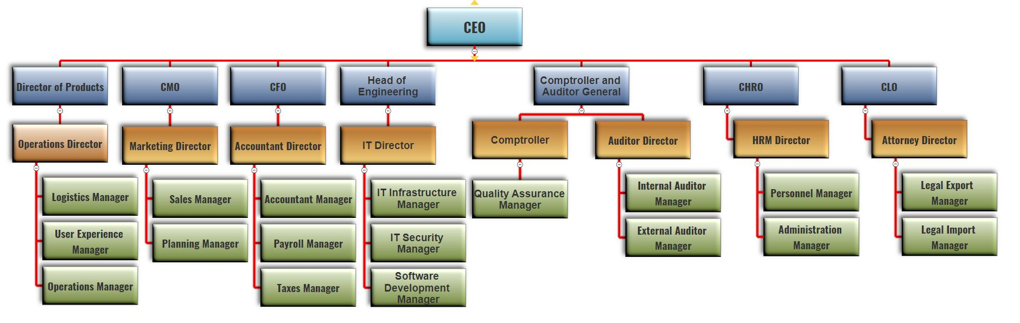

Figure 1 C-level structure

**1.4 Responsibilities within Border Master’s departments**

Table 1 below shows the responsibilities within Border Master’s departments.

|  |  |
| --- | --- |
| **Actor** | **Responsibility** |
| Chief Executive Officer (CEO) | * Develop high quality strategies to achieve short-term and long-term goals. * Leading subordinates to reach the same strategy goal as a team * Overseeing all operations and business activities to ensure they produce the desired results and are consistent with the overall strategy and mission |
| Director of Products | * Owner of all the products that the company produces and formulate objectives with the help of other directors to improve the quality and costs of the products |
| Chief Marketing Officer (CMO) | * Develop and implement a cohesive marketing plan to increase brand awareness, setting current and long-term goals for his department in order to align them to the company’s need. |
| Chief financial Officer (CFO) | * Oversee driving the company’s financial planning and performing risk management by analysing financial investments and liabilities. |
| Head of Engineering | * In charge to provide support to all the IT Systems and Services, develop strategies for proper use of the technology resources, evaluate new systems and infrastructure and ensure technologies are used efficiently, profitably and securely. |
| Comptroller and Auditor General | * Develop a strategy to ensure the quality of the products and setting internal governance policies enhancing them with audits. |
| Chief Human Resource Officer (CHRO) | * Craft the company’s vision and mission, develop strategic HR plans and policies for hiring, guiding and evaluating human resources. |
| Chief Legal Officer (CLO) | * Providing expert and strategic legal advice to management and evaluates impact of any decision or course of action the company decide to take. |
| Operations Director | * Supervise the day to day running of business to ensure smooth progress and develop a plan to obtain a meaningful dashboard. |

|  |  |
| --- | --- |
| **Actor** | **Responsibility** |
| Marketing Director | * Design and implement comprehensive marketing strategies to create awareness of the company’s business activities and produce ideas for promotional events or activities and organizing them efficiently to increase the value of the company products. |
| Accountant Director | * Develop a strategy to support business decision-making based on financial data from the company, oversee accounting procedures to ensure compliance with regulations, discuss financial, budgeting and forecasting reports with the chief officers of the company. |
| IT Director | * In charge of the IT Systems, Services and platforms that the enterprise use, analyse the business requirements of all departments to determine their technology needs and establish IT policies and systems to support the implementation of strategies set by the chief officers of the company. |
| Comptroller | * Execute a strategy to enhance services and product quality with short-term and long-term objectives. Develop product quality policies. |
| Auditor Director | * Oversee and direct a compliant and accurate auditing process and ensure efficiency of internal controls |
| Human Resource Management Director | * Develop a plan for benefits like health, family, money compensation for the employees and integrate strategies for performance evaluation on the different areas and personal development. |
| Attorney Director | * In charge of the regulations and legal parameters that his department produces for the different products and countries that border master enterprise import or export. |
| Logistics Manager | * Oversees develop and defining the multiple connecting points (haulers, ferry boats or airplanes) and the best deliver path for each package. |
| User Experience Manager | * Develop strategies to review the level of conformance of company’s users based on surveys and on the web reviews. |

|  |  |
| --- | --- |
| **Actor** | **Responsibility** |
| Operations Manager | * In charge of all the export and import transactions generated on our system, his staff and him are the front line of support in case a transaction get stuck. |
| Sales Manager | * In charge of the marketing part of the business generating advertising and promotions that make sense for our products and generate value for our clients. |
| Planning Manager | * In charge to anticipate possible eventualities or risks that the enterprise may face soon and whilst the brand keeps growing strong in the market. |
| Accountant Manager | * Manager job is to manage and oversees the daily operations of the accounting department, his staff monitor and analyse accounting data to produce financial reports or statements, he must establish and enforce proper accounting methods, policies and principles in benefit of the company. |
| Payroll Manager | * Oversees paying on time to the employees of the company, to be able to do that his staff oversee collecting the timesheets and downloading the timesheets, calculate bonus and allowances and prepare money compensation for the end of the month. |
| Taxes Manager | * Oversees the tax reports every quarter of year and his staff estimate and track the tax refunds and prepare tax payments. |
| IT Infrastructure Manager | * This manager and his staff oversee manage, supervise, buy and provide advice on infrastructure systems, identify user needs and requirement and extend the infrastructure until it meets user criteria. |

|  |  |
| --- | --- |
| **Actor** | **Responsibility** |
| Quality Assurance Manager | * Oversees devising and reviewing specifications for import and export products and to supervise the processes, the staff oversee customer needs and requirements to develop effective quality control processes. |
| Internal Auditor Manager | * Oversee and direct a compliant and accurate internal auditing processes. Performing audits on systems, operations and accounts with in the different departments of the company. |
| External Auditor Manager | * Inspecting financial statements to catch errors, misstatements and fraud, Reporting audit findings and recommending improvements |
| Personnel Manager | * Setting objectives for the HR team and tracking progress. * Designing and implementing company policies that promote a healthy work environment * Developing compensation and benefits plans |
| Administration Manager | * Set a plan for strategic goals inside the company, supervising human staff from different departments and liaising with chief’s officers to make decisions for operational activities. |
| Legal Export Manager | * Provide accurate and timely counsel to executives, administrators and operators in the legal exporting view. |
| Legal Import Manager | * Provide accurate and timely counsel to executives, administrators and operators in the legal importing view. |

Table 1 The responsibilities within Border Master’s departments

**1.5 Leadership: responsibility assignment matrix (RACI)**

Most of the projects fail not because of lack of effort to implement them, but the absence of organization and well-defined responsibilities of important stakeholders. In fact, when that roles and responsibilities are not well defined, there is a tendency to the failure in the implementation and utilization of the system.

To overcome the challenge mentioned above, RACI (Responsible, Accountable, Consulted and Informed) matrix was designed to clarify how actors will be interacting with the Border Master system and their clear roles to avoid confusion towards the use of the system. Table 2 below illustrates the RACI matrix.

|  |  |  |  |  |  |  |  |  |  |  |  |  |
| --- | --- | --- | --- | --- | --- | --- | --- | --- | --- | --- | --- | --- |
| **Steps** | **Actions** | **CEO** | **Director of Products** | **VP Marketing** | **VP Finance** | **Head of Engineering** | **Controller and Auditor General** | **Director of**  **Operations** | **Marketing director** | **Accountant Manager** | **IT**  **Director** | **Head of Legal**  **Department** |
| 1 | Products’ payments |  | I | I | A |  | I | C | I | R |  |  |
| 2 | Cancel orders |  | I | I | A |  |  | C | I | R |  | I |
| 3 | Provide shipping updates |  |  |  |  | A |  | C | I |  | R |  |
| 4 | Shipping process |  | I |  |  |  |  | R/A | C |  |  | I |
| 5 | Update records |  | I | I | C | A/C | I | I | C | I | R | I |
| 6 | Databases  management |  |  |  |  | A/C |  | I |  |  | R |  |
| 7 | Technical support | I | I | I | I | A | I | I | I | I | R/C | I |
| 8 | Supply imported /exported products | I | I | C | A |  | I | R | I | I |  | I |
| 9 | Legal cases | C | I | I | I | I | I | C | I | I | I | R/A |
| 10 | Risk management | I |  |  |  |  |  | I |  | I | C | R |

Table 2 The RACI matrix

**Chapter 2 Strategy**

**2.1 Background**

This chapter focuses on the second principle of IT Governance which is strategy. In Border Master system, the main aim is establishing a secure information system through managing the risk. At the beginning, it is significant to explain the functionalities and data processes of the Border Master system. Then, risk management is a vital aspect to identify the possible risks and mitigate them. Finally, building a security architecture can provide a clear vision to build a secure system.

**2.2 System functionality: Use case diagram**

In system development, use cases are a technology that captures potential needs when developing new systems or software upgrades. Each use case provides one or more scenarios that reveal how the system interacts with the end user or other system to achieve a clear business goal. In other words, using the use case observation system, developers can separate the system implementation from the system objectives and help understand the most important part - to meet user requirements and expectations without being immersed in implementation details. Generally, use cases are co-authored by software developers and end users who can see the system provides the function, first determine the scope of the system and then in-depth project work.

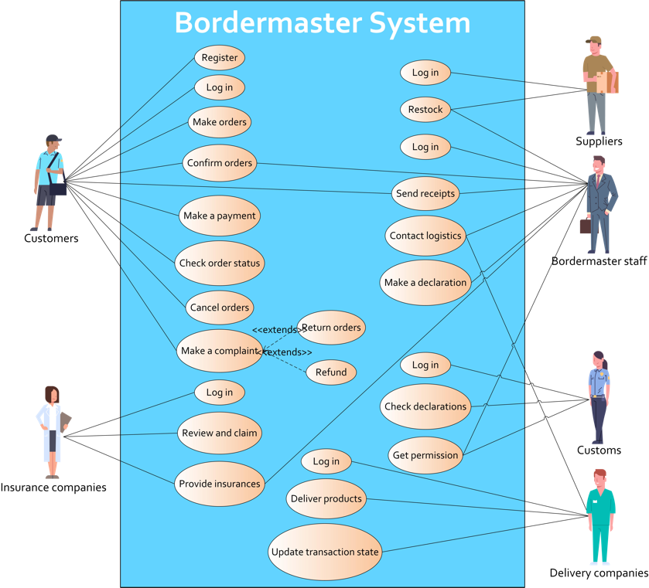

Figure 2 The use case diagram

In figure 2, the use case of Border Master system describes six main actors in the system and their actions. Among these, Border Master staff can be divided into many parts, such as cashiers and accountants in financial department, consultants in legal department, programmers in IT department, HR managers in HR department, they all have their own duties during the work. The interaction between each actor and the system as well as the respond from the system will be represented in the following:

1. **Customers**

* Description: Border Master is a system which provides import/export services for customers, so customers play a primary role in the system. In brief, what the customers should do is access Border Master system through Internet and propose their requirements.
* Pre-condition: users must register to the system before access to the main functions of the system.
* Post-condition: users get feedback from system if an order is fulfilled and displays correct status.
* Basic flows:
* User makes orders through the system:
* User inputs username and password to log in to the system
* System makes verification to user’s identity
* User decides import or export
* System displays graphical user interface of import or export
* User inputs the information of goods and places of export and import
* System add the requirement to the orders
* User confirms the order
* System redirects to the payment page
* User makes the payment
* System escrows the payment and gives receipts
* System informs delivery to the user
* User confirms delivery and give feedback
* System records feedback
* Alternative flows:
* User withdraws the orders:
* User inputs username and password to log in to the system
* System makes verification to user’s identity
* User requests for checking orders
* System displays the information of orders
* User request for withdrawing the orders
* System revokes the orders and refunds
* User return orders:
* User inputs username and password to log in to the system
* System makes verification to user’s identity
* User contacts with customer service about returning orders
* System sends details about returning orders
* User confirms returned order with the system
* System refunds
* Specific requirements
* Password matches incorrectly:
* Password error: system prompts error information, return to the log in interface
* Continuous password error: if the password matches error three times in a row, the account will be locked, the system will send an email to the registered email account

**2.Border Master Staff**

* Description: the functions of Border Master staff are confirming customers’ orders and contacting suppliers, logistics and insurance companies through the system, to accomplish the requirements from customers.
* Pre-condition: customers must make orders or return them.
* Post-condition: users get feedback from the system if an order is fulfilled and displays correct status.
* Basic flows:
* Confirm orders and implement customers’ requirements through the system:
* User inputs username and password to log in to the system
* System makes verification to user’s identity
* User proofs the order information
* User inputs declaration documents and sends to customs
* System sends email to customs
* User inputs information about goods and provides to suppliers
* System sends an email to suppliers
* User sends an insurance application to the insurance company
* System sends the email to the insurance company
* User sends a delivery application to the logistics company
* System sends the email to the logistics company
* Alternative flows:
* User cancel orders:
* User inputs username and password to log in to the system
* System makes verification to user’s identity
* User alters the status of the order to “cancelled”
* System sends emails to customs, suppliers, logistics and insurance companies
* System confirms the feedbacks from customs, suppliers, logistics and insurance companies
* System refunds
* User return orders:
* User inputs username and password to log in to the system
* System makes verification to user’s identity
* User alters the status of the order to “returned”
* System sends emails to suppliers and logistics companies
* System confirms the feedbacks from suppliers and logistics companies
* System refunds
* Specific requirements:
* Password matches incorrectly:
* Password error: system prompts error information, return to the log in interface
* Continuous password error: if password matches error three times in a row, the account will be locked, the system will send email to the registered email account

1. **Suppliers**

* Description: suppliers confirm order information from the system through emails and prepare goods, waiting for logistics companies to gather.
* Pre-condition: system must send order emails to suppliers.
* Post-condition: Users get feedback from the system.
* Basic flows:

Confirm orders and provide goods:

* User inputs username and password to log in to the system
* System makes verification to user’s identity
* User get the order information
* User uploads goods preparation status
* System saves goods preparation status
* User confirms delivery
* System checks delivery with logistics company
* System checks the completion of order
* System release payment
* Alternative flows:
* User cancel orders:
* User inputs username and password to log in to the system
* System makes verification to user’s identity
* User confirms the cancelation information
* User return orders:
* User inputs username and password to log in to the system
* System makes verification to user’s identity
* User confirms the return information
* System informs user about return of goods
* Specific Requirements:
* Password matches incorrectly:
* Password error: system prompts error information, return to the log in interface
* Continuous password error: if password matches error three times in a row, the account will be locked, the system will send email to the registered email account

1. **Logistics Company**

* Description: logistics company confirms order information from the system through emails and deliver goods to the destination.
* Pre-condition**: s**ystem must send order emails to the logistics company.
* Post-condition**:** users get feedback from the system.
* Basic flows**:**

**-** Confirm orders and deliver goods:

* User inputs username and password to log in to the system
* System makes verification to user’s identity
* User get the order information
* User updates goods delivery status
* System saves goods delivery status
* User confirms delivery
* System sends an email to customers
* System checks the completion of order
* System release the payment
* Alternative flows**:**
* User cancel orders:
* User inputs username and password to log in to the system
* System makes verification to user’s identity
* User confirms the cancelation information
* User return orders:
* User inputs username and password to log in to the system
* System makes verification to user’s identity
* User confirms the return information
* User uploads return status
* System saves return status
* Insurance claim:
* User uploads incident information
* System saves incident information and claim for the insurance compensation
* System sends insurance indemnity to customers
* Specific requirements:
* Password matches incorrectly:
* Password error: system prompts error information, return to the log in interface
* Continuous password error: if password matches error three times in a row, the account will be locked, the system will send email to the registered email account

1. **Insurance Company**

* Description: insurance company confirms order information from the system through emails and provides insurance services.
* Pre-condition: system must send order emails to the insurance company.
* Post-condition: users get feedback from the system.
* Basic flows:
* Confirm orders and deliver goods:
* User inputs username and password to log in to the system
* System makes verification to user’s identity
* User get the order information
* User uploads insurance contracts and require signing
* System saves insurance contracts and makes payment
* User dispatches workers to supervise delivering and loading/ uploading
* Alternative flows:
* User cancel orders:
* User inputs username and password to log in to the system
* System makes verification to user’s identity
* User confirms the cancelation information
* Insurance claim:
* User inputs username and password to log in to the system
* System makes verification to user’s identity
* User confirms the incident situation
* User sends insurance indemnity to system
* System confirms insurance indemnity
* Specific requirements:
* Password matches incorrectly:
* Password error: system prompts error information, return to the log in interface
* Continuous password error: if password matches error three times in a row, the account will be locked, the system will send email to the registered email account

1. **Customs**

* Description: customs check customs declaration documents and give permissions.
* Pre-condition: logistics companies must upload delivery status of entering customs.
* Post-condition**:** goods enters customs or sends back.
* Basic Flows**:**
* confirm orders and deliver goods:
* User inputs username and password to log in to the system
* System makes verification to user’s identity
* User checks customs declaration documents
* User uploads customs permit
* System saves customs permit and inform logistics companies
* Alternative flows**:**
* user cancel orders:
* User inputs username and password to log in to the system
* System makes verification to user’s identity
* User confirms the cancelation information
* Specific requirements:
* Password matches incorrectly:
* Password error: system prompts error information, return to the log in interface
* Continuous password error: if password matches error three times in a row, the account will be locked, the system will send email to the registered email account
  + 1. **Misuse case diagram**

Misuse case is a tool using to represent the cases which are illegal to happen in the system. Figure 3 below shows these cases which might happen in the Border Master system. Crooks may steal company’s equipment and leak company’s data and information. Hackers might do several misuse cases such as compromise the system, deny access and modify content. Rivals may use virus, destroy IT system and data, supervise and report the possible illegal products and documents and recruit staff as spies, steal valuable information.

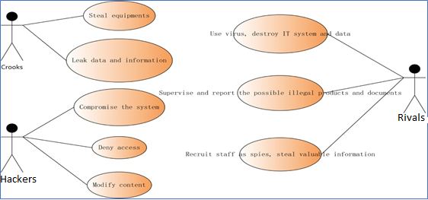

Figure 3 The misuse case diagram

**2.3. System process: Data flow diagram**

In Border Master system, five actors should interact with the system to perform numerous tasks considering the roles and responsibilities of each actor. Figure 4 below illustrates the flow of data in this system.

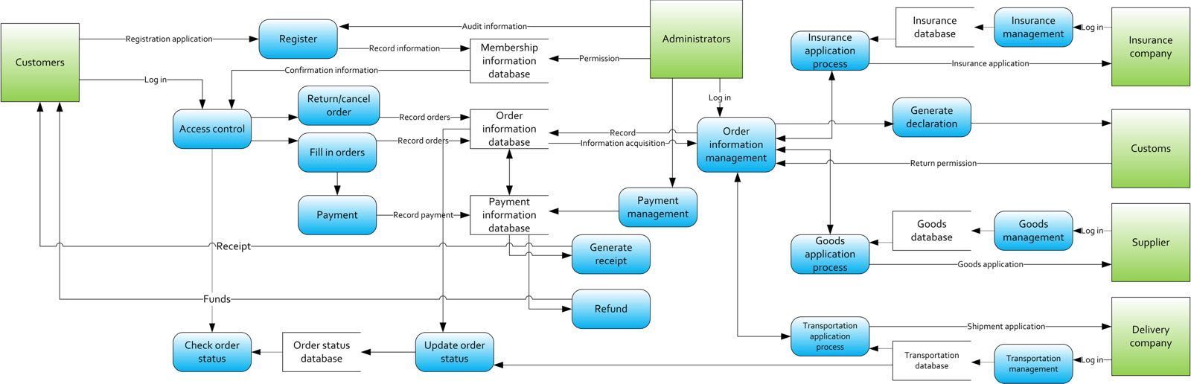

Figure 4 The data flow diagram

1. **Customers**

Initially the customers should be able to register into the system so that they could log in and perform numerous tasks. The registration process should capture detailed information about the customers such as username, password, names, E-mail and their physical address. To access the system, customers should identify themselves by providing username and password. Furthermore, other security countermeasures including token and credential encryption should be used to reinforce the security and protect the system from threats and malicious users who can compromise the system.

After logging into the system, customer can do many tasks such as making order and payment, cancelling orders and tracking updates on shipping process of the ordered products. The system should be configured and automated to provide notifications to the customers’ e-mails for information purposes.

1. **Administrators**

This category consists of administrators of the IT system. They constitute the super users, masters and technical engineers of the systems. They could oversee and control all functionalities of the system as they possess full rights to perform administrative tasks on the system. In addition, they could manage databases related to customers’ information, orders’ information, payment information, products, transportation and insurance. Furthermore, they can provide any technical support related to the system specially to fix security issues that occurs during the utilization of the system.

1. **Insurance companies**

The staff in charge of providing insurance services will log into the system to manage insurances related to imported and exported products. They can be able to check for users’ information and manage insurance application processes and orders’ information. Furthermore, they should have access to insurance contacts and other different related documents for analysis and process purposes.

1. **Customs**

Access should be provided to customs, official staff in the Government, who will oversee, audit and analyse transactions and tax declarations related to the imports and exports, to ensure that companies fulfils their duties towards government’s rules and regulations.

1. **Suppliers**

Companies that supply the products should use the system to check for requests from customers and arrange ways to supplier imported and exported products. They should have access to update records in the database that stores the products.

1. **Delivery companies**

Delivery companies should access the transportation databases to manage transportation and shipment processes. They can be obliged to update the system with accurate information on order status so that users can be able to track the shipping process in real time.

**2.4. Risk Management**

The risks are not only the chance or probability of loss, but also the effect of uncertainty on objectives (ISO31000, 2009). In Border Master system, the risks might include unpredictable events which have a negative impact on the system. The main aim of managing the risks is keeping the Border Mater system secure through identifying the most kinds of risks and take a right decision about each one.

**2.4.1 Risk management process**

According to (Papamichail, 2009), the processes of managing the risks are risk identification, risk assessment and risk treatment plan. The Figure 5 below shows these processes.

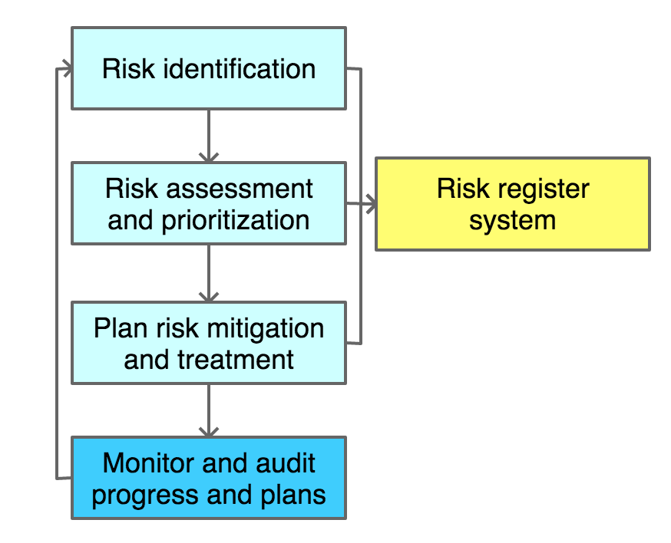

Figure 5 The processes of risk management

**2.4.1.1 Risk modelling**

For the risk management model, each member evolved in the process of risk management should always report the situation of their risk environment and how their works are done, as well as what they did when risks come. However, we should be aware that no models could predict and include everything, and no models will stay still for a long time without change. In Border Master system, each actor should keep the model dynamic and always report on what they faced and what they did to help build the risk management model better.

For the case study of the Border Master system in this report, a mature misuse case is like an initial model risk management. With the misuse case, we can predict some of the risks when bad situations happen, and be aware of most of the risks mentioned in the misuse case. In other standard ways, we can model the risks with the Political, Economic, Social, Technological, Environmental and legal framework (PESTEL). The political part could be the change of government. The economic part could be the financial crisis exchange rate increased HIR costs higher taxes. The social part could be consumers stop using delivery companies as their lifestyle. The technological part could be the launch of new devices or modern technologies. The environmental part could be regular floods or tsunami or volcano. The part could be change of legislation partnerships with local businesses.

**2.4.2 Standard risk assessment**

In terms of risk management, there are many techniques to assess the risk and take the right decision according to its score. In Border Master system, both Confidentiality, Integrity and Availability (CIA) and Risk Assessment Codes (RACs) approaches are used to calculate the score of each risk.

**2.4.2.1** **Confidentiality, Integrity and Availability (CIA)**

Confidentiality is to ensure that only authorized users can access to the data. Integrity is the completeness of data to make sure that data is reliable. Availability is providing the ready information for authorized users.

This model designs to provide CIA information security with in Border Master system. Table 3 below presents this model.

|  |  |  |  |  |  |  |  |  |
| --- | --- | --- | --- | --- | --- | --- | --- | --- |
| **The risk** | **The owner** | **C** | **I** | **A** | **Impact** | | **Probability** | **The score** |
| Staff Information | HR Manager | 3 | 5 | 3 | 3.6 | 3 | | 12 |
| Network Information | IT Manager | 4 | 4 | 5 | 4.3 | 3 | | 15 |
| Database system | IT Manager | 5 | 5 | 5 | 5 | 4 | | 20 |
| Financial Information | Financial Manager | 5 | 5 | 3 | 4.3 | 3 | | 12 |
| Insurance Information | Insurance Manager | 3 | 4 | 3 | 3.3 | 2 | | 6 |
| Products Information | Supplier Manager | 3 | 4 | 4 | 3.6 | 3 | | 12 |
| Delivery Information | Delivery Manger | 2 | 5 | 4 | 3.6 | 2 | | 9 |

Table 3 The CIA assessment model

To calculate the score of each risk in the previous table, the following steps explain this procure:

* Identifying the risk which may threat the system.
* Assign the owner for each asset.
* Give C, I and A resendable values according to the below scale:

1 is public information and 5 is top secret.

* Calculate the impact which is the average of CIA values.
* Calculate the probability of occurring which is the average of threat and vulnerability.
* Calculate the score of the risk which is the result of multiplying impact and probability.
* Match the score with the risk matrix, Table 4 below shows these values.

|  |  |
| --- | --- |
| **The score** | **The risk** |
| 0-5 | Low (Acceptable) |
| 6-10 | Moderate |
| 11-15 | High |
| 16-25 | Extremely high (Unacceptable) |

Table 4 The risk matrix

**2.4.2.2** **Risk Assessment Codes (RACs)**

RAC model uses a combination of the probability of occurring and the impact to assess the risk. In table 3, the risks are divided into six parts which are physical damage, hacking attacks, equipment breakdown, application breach, social status and legal risk.

|  |  |  |  |  |
| --- | --- | --- | --- | --- |
| **The risk** | **Type** | **Impact** | **Probability** | **The score** |
| Physical damage | Natural disaster | 5 | 3 | 15 |
| Fires | 5 | 2 | 10 |
| Unavailable Power | 3 | 2 | 6 |
| Hacking attacks | DDOS | 5 | 4 | 20 |
| Malware | 4 | 4 | 16 |
| Application breach | Overdue patching | 4 | 3 | 12 |
| Computation errors | 3 | 3 | 9 |
| Equipment breakdown | Unavailable Network | 3 | 4 | 12 |
| System Failure | 5 | 4 | 20 |
| Legal risk | Staff fraud/theft | 4 | 3 | 12 |
| Social status | Loss reputation | 3 | 3 | 9 |

Table 5 The RAC model

**2.4.3 Risk decision**

Risk decision is a decision made by the Border Master system’s authority leader teams to accept a treatment plan or not a given risk function in preference to accepting the risks, or in preference to taking no action and accepting the risks. (Poppe, 2016)

In this part of the whole process of risk management, we mainly focus on how to do with the risks accept or mitigate or overcome the risks, and to obtain a modelling risk management system for the future use. Figure 6 below shows the risk decision.

Figure 6 The risk decision

**Risk avoidance and risk reduction**

Adjust program requirements or constraints to eliminate or reduce the risk. This adjustment could be accommodated by a change in funding, schedule, or technical requirements. (MITRE, n.d.) However, we should be aware that we can never predict or avoid all the risks.

**Accept the risks**

The actors evolved should be aware that there exist some risks which will be difficult to handle, or will cost a lot to mitigation or overcome the problems. In that case, we may choose to accept and live with the risks or potential risks.

**Transfer the risks**

This decision is related to the responsibility and different focusing part of the stakeholders who can transfer the risks to others with more authority or responsibility or influence.

**2.4.4 Risk mitigation and treatment plan**

For the authority leader team of the Border Master system, they should be aware of it and be aware of how to balance the cost of management and the cost of the risks.

To learn about the mitigation and treatment plan, firstly, we introduced the stakeholder analysis model to measure the influence and power of the actors in the system.

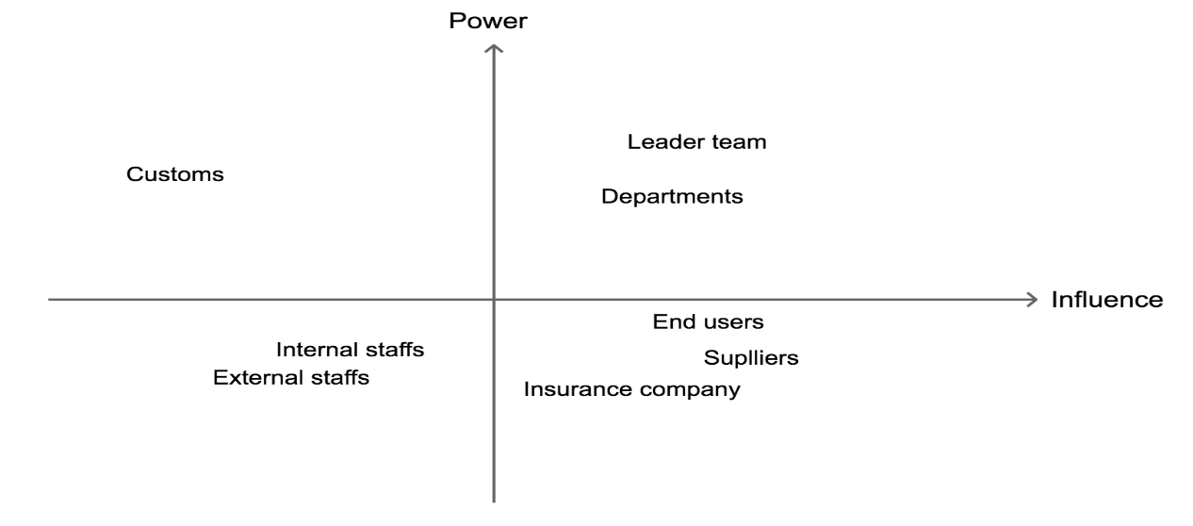

Figure 7 The stakeholder analysis model

For different stakeholders, the risks they are going to meet are different. And the impact or cost of the treatments of the risks will influence them differently. For example, of all the criteria to be concerned, the leader team will value the economic cost of human resources much more than staffs, and end users will value the time cost of delivery much more than customs. This means the criteria will even be different among all the stakeholders, and for each stakeholder, the best solutions of the risks will be different. However, we should analysis the importance of the stakeholders and think about which of them should be weight most and which stakeholder will not matter that much to our system. From the model showed in figure 7 above, customs are not the stakeholder that we should considered the most when making the decision of handling risks, because they will not be influenced by the risks that much, and yet no matter how we decide to handle the risks, they do not care that much with the influence as other actors in this model. What is more, insurance company is like an outsider part of the system who have low power, which means when making the decision about risk management, they do not have the weight in decision.

In the risk assessment above, almost all the potential risks are illustrated. In risk mitigation and treatment plan, considering some treatments and mapped to each risk have been identified on the security architecture. To fully understand the risks and find solutions, a technical theory and details about cyber risks and about implementation of cyber communication will be referred.

## **1 Risk mitigation for physical damage**

In Border Master system, there are two different physical locations of data centres. This means if physical damage such as natural disaster or fire happen on the data centre1, all the data stored in data centre1 might be lost and unable to recover. However, backup system is prepared to save the principal data in data centre1 for the last 12 hours in data Centre 2.

## **Risk mitigation for hacking attacks**

In this section, risk treatment will be introduced based on various kinds of hacking behaviour.

### **Distributed denial-of-service attack (DDoS)**

DDoS is the abbreviation for distributed denial-of-service attack which is a kind of hack behaviour. However, the implementation of DDoS can be different, to the damage it can make, therefore, different specific explanation and resolution will be listed respectively to cover all the possible hacking damage of the system.

**(1) SYN FLOOD attack**

A normal network communication between a client and a sever can be divided into three steps. The first step, the client will send a connection request to the server. In the second step, the server acknowledges the request and response to the client. In the last step, the client sends a message to client to answer the response and the connection will be established.

However, in a hacker behaviour using SYN FLOOF, several zombie computers that controlled by hackers using virus would constantly send connection request to the server of the system, but zombie computers would deliberately not to answer the response from the server as it is mentioned in the last step, in such case, the server would have to wait for about one minute. A massive volume of requests from numbers of zombie computers would consume most of the system resources of the sever, this would cause the server has no resource to deal with the requests from valid users.

To protect the system from SYN flood attacking, two different methods can be used to mitigate the risk. First, on the server, the minimum SYN timeout can be set as a brief time like 30 seconds, so the server would not have to wait a long time then abandon an invalid request. Compared with the servers with a minimum SYN timeout as 1 minute, the server can bear with double volume of SYN FLOOD attack. However, this method has its own shortage, a normal connection request from a valid user may get regarded as hacker behaviour if the client cannot response the server in time because of a bad network connection.

The second method is that turn up the SYN FLOOD detection function on the first firewall, the firewall can detect how many times a same IP address tries to connect the server, and the firewall can ignore the connection request from the IP address access the server too frequently in a short time, in this way, the SYN FLOOD attack can be prevented effectively.

1. **SMURF attack**

The hacker might send a ICMP data package to a network broadcast address and change the source address of this data package to the address of the target server (the server of the system), this broadcast address may be shared with a huge number of computers, and all of these computers will send an echo response message to the target server, thereby, a large amount of response message would be sent to the target server and consume massive sources of the server. Therefore, the server cannot deal with the connection request from other valid users.

To prevent the Border Master system from SMURF attack, the firewall in the system can reject the echo response messages coming from a IP address that the system did not try to connect. Hence, only the response messages from where only valid users can get through the firewall and reach the server.

1. **LAND attack**

Using this method, hackers will use many zombie computers to send connection requests and change the source IP address to the address of the target server. By doing so, the server would establish connections with the server itself, each connection will survive and last for minutes and then get abandoned, a plenty of useless connections would occupy massive source, the speed of the Linux system in the server becomes extremely slow and requests from valid users cannot be handled effectively.

To defence the Border Master from LAND attack, the fire had configured to accept connection request whose IP address is as same as the IP address of the server, so to stop from establishing a useless connection with the server itself.

1. **TEAR DROP attack**

When transferring a huge data package through a network from a client to a server, the data package will be divided into several small packages, and they will be combined again after arriving the server, each small package carries a position information to present its position in the original data package, so the server can finish the combination. However, if the hackers deliberately change the position information of small package, leading to that the server cannot fit these small data packages together properly, the system of server is likely to crash or reboot.

In Border Master, the server has a filter to put together different small data packages that come from the same original data package by match their source IP address and destination IP address. Afterwards, detecting if the position information is correct before really combining them, small packages with incorrect position information will be abandoned directly. As a result, TEAR DROP attack will not be a threat to the server.

## **3 Risk mitigation for Malware**

* **virus**

A DMZ is short for demilitarized zone which is set in the Border Master system, DMZ can isolate web application server and database server from the web front server, because the web front servers can be directly connected with internet, they are more likely to get attacked by virus. However, web servers put in DMZ which caused that virus cannot reach other important servers but only web front servers. Once the virus gets blocked, programmers just need to fix the web front servers and data in other servers will be protected as well.

There are two firewalls in the DMZ, the first firewall aims to prevent the system from hacking and the second one aims to manage the access from the DMZ to internal system where important servers and databases are. Therefore, even the virus can get through the firewall, it is difficult to pass the second firewall.

A DMZ can meet such requirements to protect internal system and maintain normal network access at the same time as the following:

1. the internal system can access the internet, to achieve this, the firewall in the system is able to translate a domain name into a web IP address.
2. The internal system can access the DMZ, because the administrators in the internal system need to use and maintain the servers in the DMZ.
3. The internet cannot access the internal system directly but must pass the DMZ first. The internal system saves important data of border master that only the administrators can visit.
4. The internet can build connection with servers in DMZ, because the system needs to provide service to users.
5. The data coming from DMZ to internal system needs to be checked and tested when passing the second firewall to protect the internal system.

**2.5 Border Master Cyber Security**

**2.5.1 Cyber Security Goals**

To create an integrated border master system, it is essential to involve the security of the entire system which is the base of the Border Master system promotion. In terms of the security service model, there are six aspects which are authentication, authorization control, audit confirmation, data confidentiality, data integrity and availability.

**2.5.2 Information Security Management**

To build a case about how to solve the security of the system, the security model become an essential problem to be solved. In the past, there is not a strict and unified standard about the information security system structure because people has the different opinions about the information security in the different areas and times. At the early stage, people focus on the static information security system which is mainly about the protection. However, with the development of the information security, people realize the importance of the dynamic and procedural requirements for the development of the information security.

**2.5.3 Network security**

**2.5.3.1 PDR model**

IDS is short for Intrusion-detection system. It can monitor the condition of the network and the system through the software and the hardware. Furthermore, it can also be based on the certain security policies to try to find the various attack attempts, attack behaviours or the attack results to guarantee the confidentiality, integrity and availability of the network system resources. As more and more IDS devices appear, ISS company propose the early IDS model is PDR which is composed of protection, detection and response. These parts become a loop, which is from protection to detection, from detection to response and from response to protection. Figure 8 below shows the PDR model.

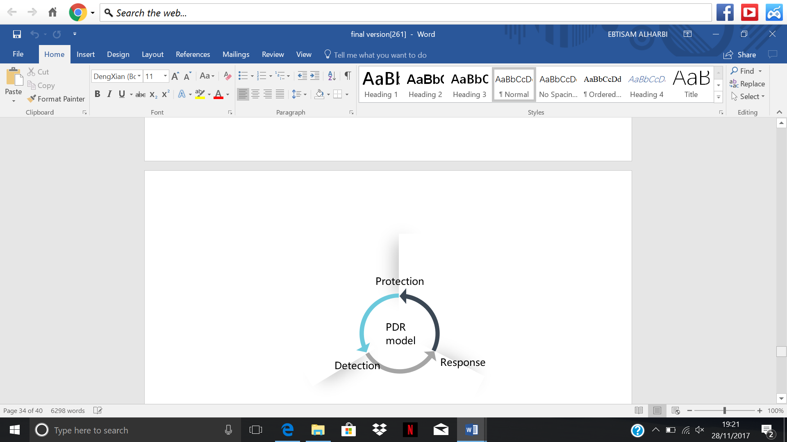

Figure 8 The PDR model

The PDR model is based on the IDS devices; therefore, the whole three parts can be corresponding to the actual products and functions. For example, protection is related to the firewall, detection is related to the IDS and response is related to the combination of firewall and IDS. Consequences, the automatic detection and automatic response, it does not spend too much time on detection and response. As a result, it can guarantee the security of the system. Protection is the first step of the security, which need to install all necessary patches, increase security policy level and install firewall. Detection is the real-time monitoring of the network by using some effective methods and find out the abnormal situations, for example the service status is not stable, or the service stops. Besides, detection can also find out the attack pattern. And response is to ask the system to respond promptly after it find out the attack attempt or being attacked. In other word, response means the further protection.

**2.5.3.2 PPDRR model**

Besides, PDR model has a range of variations. The other one that should be mentioned is PPDR model. Compared to the PDR model, PPDR model add another concept called Policy, which means PDR model is under controlled by the policy. And because of policy, the entire model become more integrated and it can connect with the management.

When it comes to the PPDRR model, the security model comes into a new level. It is like PDR model, the only difference is that PPDRR model treat restore as the same level with protection, detection, policy and recovery. Restore is based on many backups to enable emergency response recovery mechanism for instantaneous system recovery and achieve high-speed, reliable backup for heterogeneous storage and heterogeneous environments. Protection, detection, response, policy and restore constitute a complete and dynamic security cycle. Figure 9 below shows this model.

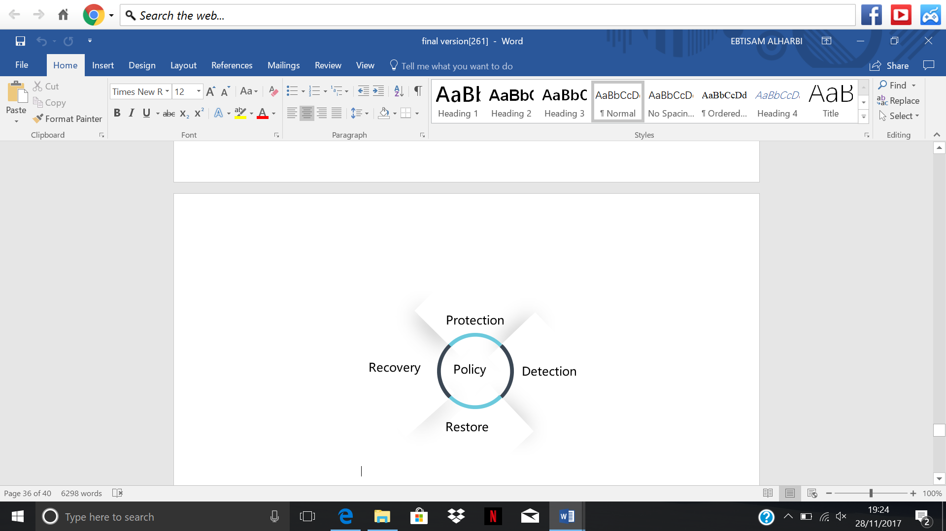

Figure 9 The PPDRR model

**2.5.4 Authentication and Authorization**

In terms of the security policy case, it is the basis of the entire security system, however it needs rules and regulations to make protection, detection, recovery and restore effective to be implemented. In terms of the security protection case, mainly it includes authentication system, Authority control system, boundary control and anti-virus gateway. There are many methods to certificate the identity such as software and hardware certifications. Normally, simple software certification is that users know their username and password to login the system. However, it is quite dangerous once people know others’ usernames and passwords. To solve this problem, the Border Master system will use the dynamic password to guarantee the security of the users’ information. There are many people who need to login the Border Master system to get their own information, the authority control system become significant to the system, especially the background management system, which is confidential. To control of the boundary, the Border Master system need to set multiple firewall to stop the unauthorized access. There are three firewalls in total, the first and the second firewall can stop the Internet users’ illegal access. The third one can prevent the internal users’ illegal access from the Border Master. Therefore, this protection can stop the information leaking by the internal staff.

* **Double factor of authentication**

Nowadays, a single factor of authentication is considering as a threat which has a negative impact on the information security system. This is because people have several accounts that they repeat the password for any access during their daily life. Furthermore, they do have simpleton passwords opening the gate to the hackers or scammers to steal their sensible information with phishing techniques which collect all your accounts password. Therefore, a single factor of authentication is not a viable technique to safe guard sensitive information.

The Border Master has implemented a double factor of authentication mechanism, to have a secure access control to the system in another attempt to decrease the risk of compromising sensitive data. The main advantage of this technique is combining of something that users know plus something that they have. To clarify, it is as a password and in the most cases either a physical or virtual token or a personal mobile phone that you receive messages on real time to enhance the overall security and certainly of who is logging on.

The employees will access the Border Master with a physical token that we are going to provide, since it is considered safer on controlled environments like work than the virtual version of it. In addition, the end users of the Border Master will have sent a message with a tokenizer to their registered phones, since it is required to register a phone when you create your user account with the system.

**2.5.5 Human resources security**

According to ISO/IEC17799 (2005), all users should be aware of their responsibilities for information security. To ensure that they are considered to mitigate the risk of misuse cases such as fraud or theft.

In Border Master system, we must apply some strong rules to ensure that all users are understanding their roles as the following:

* **Terms and conditions of employment**

All staffs should be aware of their responsibilities for information security. To ensure that staffs are considered for to mitigate the risk of misuse such as fraud or theft.

* **During employment**

Check the users access controls and their responsibility is significant to keep the system secure.

* **Termination or changing the employment**

Removal of access rights is essential to be sure the ex-employee cannot access the Border Master system.

* **Training development**

All users need a specific legal training to keep the system secure through raise their awareness of clean desk policy and session time-out. This training should introduce the organization’s security policies and expectations before accessing the system.

**2.5.6 Physical and environmental security**

Protecting the system from the physical threats such as steal, terrorism and vandalism is vital aspect in any business organizations.

In Border Master system, we must put strict rules to prevent such threat in the physical property as the following:

* **physical entry controls**

This means only authorized person can enter the physical property to limit the public access.

* **Working secure area**

To ensure the working areas such as offices and rooms are secure, we must have a security alarm in specific sections.

* **CCTV cameras**

These cameras can capture any illegal events in the physical property.

**2.5.7 Security Architecture**

To make sure the network security and the information security of the Border master system, it can be divided into four layers, includes the physical layer, the network layer, the system layer and the application layer. The physical layer includes some physical devices such as personal computer, mobile devices. The switch, firewall, VPN, physical lines are all in the network layer. The databases and the host computers are in the system layer. And the application layer is made by the web servers, application servers etc.

Basically, the entire Border Master system is divided into four logical areas and each area is deployed from outside to inside. The outermost layer is called the Internet zone, which is for the staffs, suppliers, customers and admin’ s client to connect to the area. DMZ area is in the first firewall and the second firewall. In this area, there are the web front servers. And the web application servers and internal database servers and backup database servers are in the area between the second and the third firewall. This is the Border Master’s application or main database area. After the third firewall, there is the external database servers which contain shipping details and encrypted data. Figure 10 shows the security architecture of Border Master System.

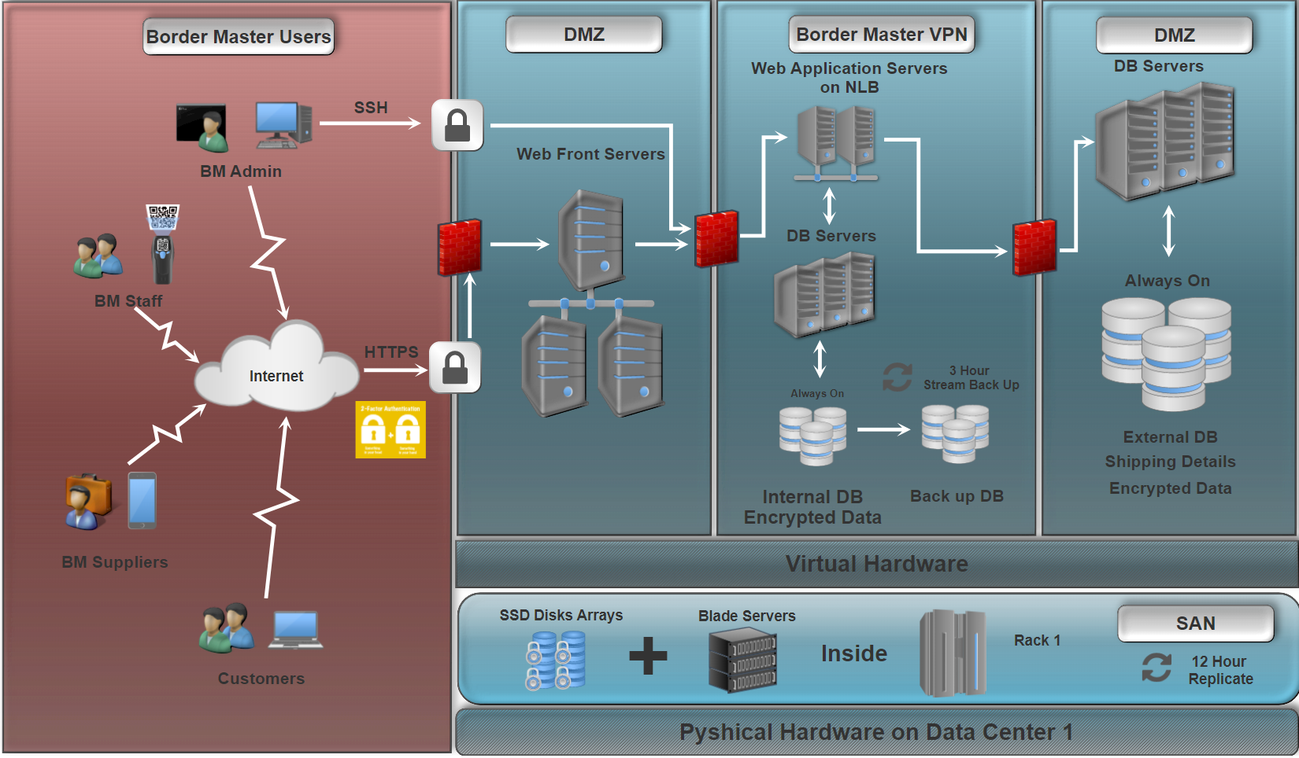

Figure 10 The Border Master security architecture

**Chapter 3 Acquisition**

**3.1 Background**

Acquisition plan is an essential aspect in the system life cycle. This principle considers the time line of the project and the total cost of ownership. In Border Master, acquisition plays a vital role during the entire lifecycle development. In this chapter, first section will focus on the project plan of the Border Master system. The second section will examine the supplier management and provide the total cost of ownership of this system.

**3.2 Project plan**

**3.2.1 Project scope**

The main objective of this project is to establish an importing and exporting information management system with Client/Server structure. The Border Master system includes software and hardware part as well as risk management, security assurance and performance testing. The expected period of this project is ten months which are about 40 weeks.

* + 1. **Requirements**
* **Functional requirements**

1. Customers can perform several functions on the system such as making orders, making payment, cancel order, returning product and refunding.
2. Insurance companies can review, claim and provide the insurance to the Border Master on customers the website.
3. Customs can check declaration from the Border Master staffs and provide permission to the products.
4. Delivery companies can deliver products and update transaction state on the website to make sure that the customers can check their orders’ state.
5. Suppliers can stock the Products and show the numbers of them on the website, to let the Border Master staffs know.

* **Non-functional requirement**

1. **Execution qualities:**

* A high cyber security is required, which means the system can prevent from hacker behaviour and virus infection.
* The response time of the website needs to be short such as 5 seconds.
* The backup for important information to deal with catastrophic loss, the position of backup should be physically isolated with the main system.
* A huge data storage is required to store an increasing number of information for staffs, customers, suppliers and products.
* A higher safety is required to stop the unauthorized access.
* A higher recovery is required, which means the entire Border Master system can be recovered until the data which is influenced can be accepted after the accident happens.

1. **Evolution qualities**

As explained in (functional-vs-non-functional-requirements, 2012), the requirements as the following:

* A high accessibility is required, which means users of the system can easily understand how to operate and the operation steps should be simple. For example, the position of login interface needs to be placed in an obvious place or the registration operation should not contain too many steps.
* A high stability is required, which means the system must be able to run for at least a month without system breakdown as well as keep a consistent performance.
* A high testability is required given that the code part would be outsourced, the deliverable result of programme must be able to smoothly pass black-box test and white-box test.
* A high maintainability is required, which means the programmer can deal with the potential fault including system breakdown.
* A high scalability is required, which means the programmer can upgrade and add a new function based on the current system.
* Laws and regulations must be considered, for example, no image containing political factors should be avoided, and improper username should not be permitted.

**3.2.3 Project schedule**

project schedule is a tool for conveying the works that needs to be done and which organizational resources are assigned to complete a definite task in the timeframe. The Border Master schedule can be regarded as a document which shows all the tasks need to be delivered on time.

* **Market research (5 weeks)**

In this stage, Chief Marketing Officer (CMO) and Marketing Director are responsible for the following:

* Week 1: market research in preparation stage

The preparation stage of the market survey is also the decision-making, design and planning stage of market research, which is the starting point of the whole research. There are three specific tasks in this stage, determining the task of investigation, designing investigation programs and setting up investigation teams.

* Week 2: practice stage

The contents of the market research are grouped into four categories as the following:

1 Market demand research

2 Competitor research

3 Business strategy research

4 Policies research

* Week 3 and 4: conduct research

When the investigation of research is completed, selecting all the relevant and important information and excluding information is significant to classify the data and make them available. Finally, presenting this information in the table to identify issues quickly.

* Week 5: write the investigative reporting.

After a comprehensive analysis, writing the report is essential to consider the changes in market conditions to evaluate the research results’ accuracy.

* **Preparation process (4 weeks)**
* Team building (3 weeks)

In Border Master, CEO and Administration Manager decide to hire new staffs in all departments of this organization. Before employment, Chief Human Resource Officer (CHRO) has the responsibility of choosing them according to their experience, knowledge and skills. After employment, User Experience Manager, arrange a preparation period for new staffs to improve their personal, technique skills. This period also includes some training classes and workshop related to security policy in Border Master.

* Infrastructure (1 week)

In this stage, choosing the equipment such as computers, desk and printer is vital to run the Border Master smoothly. Sales Manager and IT Infrastructure Manager are responsible for purchasing decisions.

* **Supplier selection (4 weeks)**

Planning Manager and Sales Manager are responsible for the following:

* Week1: marking the suppliers with a score.

We need to give a score for each supplier with a score of their important element. The main characteristics of the suppliers are listed in figure 11 below. In this part, after getting the list of the characteristics and marked them of different suppliers, we should give a weight of each element to get a final score for comparing different suppliers afterwards.

Figure 11Supplier characteristics

* Week 2: identify proper suppliers

with the scores of each supplier, we can now get a range of suppliers and analyse them in detail to find the best one, e.g. which are our suppliers now, which are our past suppliers, who are their best competitors, in what structure are they providing their products or services etc.

* Week 3: holding meeting with suppliers

With the best supplier we have chosen for our system, we need to make it clear about the details for further cooperation.

However, we can always go back to the first process and find another best supplier again if we cannot make it good for both our system and that supplier we chosen and negotiate before.

* Week 4: signing the contract

It will be the last and the most important process for supplier selection. If the contract is not signed, we will not be sure about the details of the supplier we will corporate in the future.

* **Information system development life cycle (DLC) (27 weeks)**

Information system development life cycle are a combination of six aspects focusing on different procedures in creating an information system to meet the users’ needs and requirements and even do better than their expectations. (Alwan, 2015) Figure 12 below shows the System Development Life Cycle(SDLC).

Figure 12 The System Development Life Cycle(SDLC)

* Week 1-4: Requirement Analysis

In this step, we have a preliminary cognition of the system’s requirements, and now it is the time to build it into a complete and clear one for a real plan.

* Week 5-8: Design the Web and Graphical User Interface(GUI)

In this part, we need to assemble the needs and requirements of hardware, software, security management, users’ needs etc. and to justify the projects, which means we need make a rule of how to plan it. At the end of this step, we need to produce a project development plan and check it more than twice before entering to next step.

* Week 9-14: Implementation

Then we will come to programming and installation. For Border Master system, it includes not only programming work, so we combine the two procedures into one implementation step. In this step, we need to construct information system and build it up.

* Week 15-17: Testing

The result of this step will be an already built-up system which has been well tested.

* Week 18-21: Evaluation

In this step, improvement of the system is important to enhance the current system.

* Week 22-27: Maintenance

In this step, we should involve everyday work of the users of Border Master system.

* + 1. **Gantt Chart**

Figure 13 below shows the project plan of Border Master system.

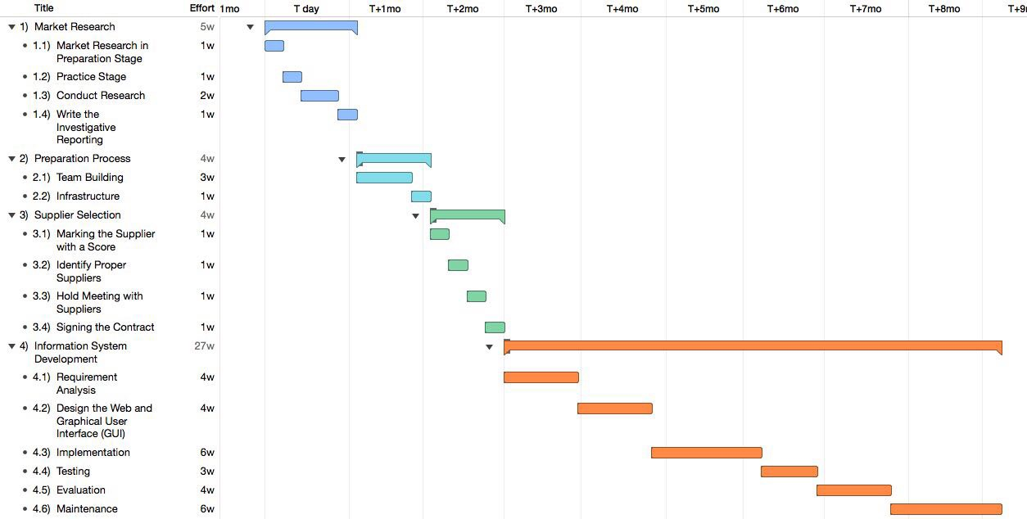

Figure 13 The project plan

* 1. **Suppliers Management**

For vendor orientation in Border Master system, supplier selection is an essential aspect. Figure 14 below illustrates the procedure for vendor orientation. (Transformance Advisors, 2017)

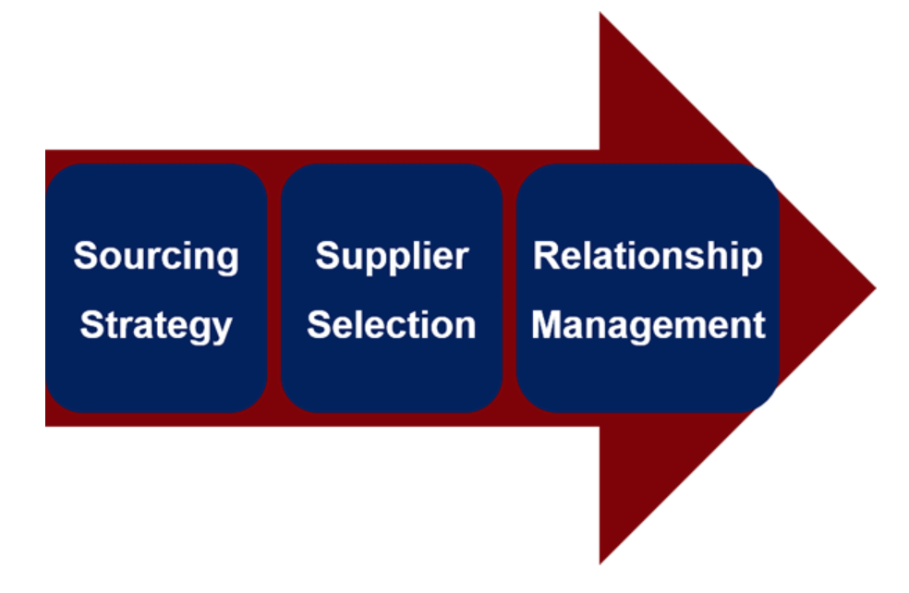

Figure 14 The procedure for vendor orientation

**3.3.1 Sourcing strategy**

Sourcing strategy is a method of making the list of suppliers and what they provide be matched with system’s requirements, and to make sure we have a knowledge of in what quality they are going to provide their products or services. To clarify, table 6 below shows a checklist for Border Master system.

|  |  |  |
| --- | --- | --- |
| **Supplier type** | **Products or services** | **Quality standard** |
| Product suppliers | Products that will be bordered and sent to users | In good condition |
| Insurance company | Insurance for the products and the process of delivering | Cover the cost for potential risks |
| Delivery company | The services of delivering products to users | With good honor |
| Legal agency | Check and assign licenses. | Familiar with the rules and laws of both country involved. |
| Outsourcing company | Software structure | In excellent quality and with a period of time’s maintenance |

Table 6 The Sourcing strategy’s checklist of suppliers

Looking at table 6, clearly, the types of suppliers, what they will provide and in which quality they should provide to our system. For all the processes afterwards, we should follow the checklist of the suppliers’ types and standards to make sure we will not meet trouble due to their fault and to reduce the risks of failure in early stage.

However, we should be aware that the market is feasibly one, and all measurement need to be changed with the changing of the rules or environment of the whole market. Therefore, during the entire life of the Border Master system, we should be careful about the changes of the market and check and correct the sourcing strategy as soon as possible when big changes are seen.

* + 1. **Supplier selection**

Suppliers are the organizations, enterprises or individuals who provide not only products but also services. As the supplier system is about choosing the corporation partner at the very beginning and we will corporate with the suppliers in the whole procedure of the project, it will be a key step for Border Master system. Table 7 below illustrates the supplier selection of Border Master. (Transformance Advisors, 2017)

|  |  |  |  |  |  |  |
| --- | --- | --- | --- | --- | --- | --- |
| **Item** | **Suppliers** | | | | | **Requirement** |
| IBM | Dell | Huawei | Samsung | Cisco |
| Servers | £60,000 |  | £35,000 |  |  | Implement two Intel Xeon E5-2600 V2 series CPUs, with at least 16 processors and 3.2 GHz each. |
| Database | £40000 |  | £25000 |  |  | Implement four Intel Xeon E7-4820 V2 series CPUs, with at least 8 processors and 2.0 GHz each. |
| RAM |  | £12000 |  | £5000 |  | Implement 128 GB, DDR3 1333MHz |
| Data Storage | £2500 |  |  | £3500 |  | Implement 34 1TB HQ 10K SAS disks |
| Switches |  |  | £6000 |  | £3000 | No less than 40 Tbps and 12500 Mpps |
| Routers | £1500 |  | £2500 | £1500 |  | Stable, high reliability and flexible with configuration |
| Firewall |  |  | £9000 |  | £6500 | Network throughput: ≥24Gbps, concurrency connection: ≥3.5 million, connection establishment: ≥180 thousand/s |

Table 7 The supplier selection of the Border Master

* + 1. **Relationship management**

For the relationship management with suppliers, we need to make it clear in the contract we make with them. What is more, in the corporation with these suppliers, we should pay attention to their latest news and changes to underestimate the relationship with them.

## Change Management

## The change management part will be about how contract changes will be managed. For the contract change management, what we are going to do is to provide a change control process to provide guidelines and procedures in managing and controlling changes of contracts (HACHERO, 2014).

And the process of contract change management will be:

* 1. Acknowledge what have will be changed
  2. Make plan of how to change the contract
  3. Hold meetings with suppliers to make sure both will accept the new contract
  4. Change and document the new contract
  5. Sign the new contract
  6. Finish the contract change

## Dispute Resolution

## Dispute resolution is the process of resolving disputes between [parties](https://en.wikipedia.org/wiki/Party_(law)). The term dispute resolution may also be used interchangeably with [conflict resolution](https://en.wikipedia.org/wiki/Conflict_resolution), where conflict styles can be used for different scenarios.

## For the contract part, as the groups have different share of the profit, and each will fight for a higher profit, of course there will be some dispute.

## However, dispute may become new chance, as that is the time when all the stakeholders will share their ideas about the profit and the cost. For us as the border master system, that means we will have a chance to double check the contract from different perspective.

## To deal with these dispute, the most important part is to listen carefully. Our only chance to make the contract be the same as we want will be listening carefully and find their errors to take bake the control. After all, this will be a chance must be cherished, because after dispute resolution, will be the signature for both for the contract, so now is the only time to change and argue the content of the contract.

## Contract Closeout

## The problems we are probably to meet are:

1. After a long time, our system and our suppliers may not be that familiar with the content of the contracts, and will make it difficult for closing the contract or corporate in the future with a new contract.

2. It is considered a less important task than other contacting tasks

As a result, in this part, we should focus on the management of the whole life of the contract, and make the responsibility of getting in touch with the supplier clear. What’s more, if we want to keep the corporation relationship with the supplier, we should keep an eye on the latest changes of them and be aware of how to change the content of the contracts in the future.

**3.4 Total Cost of Ownership (TCO)**

Total cost of ownership is a tool helping decision makers to check, mange, and reduce all costs associated with acquired assets. These assets could be: buildings, vehicles, equipment, or software systems.

In today’s business world, organizations use the TCO as a framework to make a purchasing decision and provide a better understanding of the true cost of buying a product or service from a supplier. TCO methodology assists decision makers through providing a cost of an asset and the price of operations over the long -term. (Ellram, 1993)

The main components of TCO consist of acquisition cost, installation and integration cost, operating cost, support cost and maintenance cost. Figure 15 below illustrates the components of TCO.

Acquisition cost is the cost for Border Master System to obtain the specific facilities or skills or human resources. When calculating this cost of acquisition, we should be aware of the method. We need to consider about the discounts, closing costs and all the necessary cost but should not take sales taxes into account.

The meaning of acquisition is that it is strongly connected with the efforts involved in building the new system. With it, we can measure how much work we did with each part to build the whole system.

Operating cost is the cost used to keep all the actors and the whole system itself work. There is a theory that the lower a company’s operating costs are, the more profitable it generally is (investinganswers, 2003). The operating costs could be influenced by several elements, e.g. Promotion strategy, prices for basic facilities such as electricity or transportation and the common cost for human resources which makes it complicated and difficult to calculate for complex system.

Figure 15 The components of TCO

In Border Master System, calculating the TCO constitutes a significant aspect for decision makers because the TCO can provide not only hardware costs, but all imminent costs.

Hint, TCO can be calculated by assumption because the system is under construction. Table 8 shows this assessment.

|  |  |  |  |  |  |  |
| --- | --- | --- | --- | --- | --- | --- |
| Type of cost | The asset | Category | Acquisition  Cost | Operating  Cost | Change cost | Total |
| Initial cost | Hardware | Web server | £15000 | £250 | $80 | £18300 |
| Database server | £30000 | £350 | £100 | £34500 |
| Storage devices | £600 | £50 | £25 | £675 |
| Cables | £450 | £85 | £25 | £560 |
| Security Alarm | £500 | £60 | £20 | £580 |
| Desktop | £6000 | £300 | £1000 | £7300 |
| Sub total | | | | | £61915 |
| Software | Operating System | £600 | £ 100 | £80 | £780 |
| Anti-virus | £300 | £ 60 | £30 | £ 390 |
| Firewall | £4700 | £ 100 | £ 40 | £ 6100 |
| Licenses | £200 | £ 60 | £ 30 | £290 |
| Sub total | | | | | £ 7560 |
| Personnel | Hardware | £700 | £ 150 | £100 | £950 |
| Software | £500 | £ 80 | £ 50 | £ 630 |
| Training | £15000 | £1000 | £500 | £16500 |
| Sub total | | | | | £ 18080 |
| Annual costs | Hardware | Storage devices | £ 5000 | £ 800 | £50 | £ 5850 |
| Software | Licence fees | £ 2000 | £ 800 | £ 200 | £3000 |
| Upgrades | £ 3000 | £ 500 | £ 90 | £3590 |
| Personnel | Additional training | £ 1000 | £ 800 | £ 500 | £2300 |
|  | Sub total | | | | | £102295 |
| Over 5 years | Sub total | | | | | £511475 |
| Total cost of ownership (TCO) | | £511475 | | | | |

Table 8 The total cost of ownership (TCO)

**Chapter 4 Performance**

**4.1 Background**

IT performance measurement is an essential factor in the field of IT governance. This Assessing of the IT management in an organization plays a crucial role of confirming that IT department supports the delivery of the business strategy, creates business value and reduces the risk. In Border Master, different standards should be set on to assess the performance of IT department, to help measure the desired performance and make sure the business objectives of the Border Master can be successfully realized. This chapter will focus on the desire performance of the system, evaluation and improvement, then will determine the main IT goals. The last section will analyse the security performance measurement using the balanced scoreboard and the dashboard.

* 1. **Desired Performance, Evaluation and Improvement**
     1. **Response Time**

Response time is how long a user must wait before the system returns a result after the operation is performed on the website, because the Border Master wants to provide users with a rewarding user experience that allows them to use the system effectively, short response time will be required in this situation. We defined that a response time under 5 seconds is acceptable.

### **Desired Performance**

### In the website testing area, there is a 2-5-10 principle, that if users can get the result after sending a request in 2 seconds, they would feel the system is very fast, if they can the result in 5 seconds, they would feel acceptable, but if they get the result in 5 to 10 seconds, they would reflect a bad using experience. Given that users may suffer an unexpected network connection, a response time as 2 seconds may be too harsh. That is why it is defined the standard of response time is 5 secondsin the Border Master.

### **Performance Improvement**

To shorten the response time in the Border Master, several methods can be implemented as the following:

* Encouraging the users of the Border Master to use high performance browsers such as Chrome.
* Reducing unnecessary flash and animation component on the front page so the browsers can load fewer components to save time.
* Optimizing code to reach a more effective execution using tools.
* Optimizing databases with indexes, query plans to improve the effectiveness of SQL operations.
* Purchase extra servers to improve the ability to deal with requests from users if our network traffic suggest it.

## **Maximum Concurrency**

Maximum concurrency means how many users of the website can handle simultaneously, related problems normally occur on the modules that users are most likely to use. In the Border Master, it should run as smooth as possible even under the pressure of many users accessing at the same time should be guaranteed because the system wants to provide services to majority of our clients, also to expand the business. In the meantime, the user experience cannot be affected with an increasing the number of users.

When a user successfully establishes a connection with a server, a session will be generated by the server to record some simple information of the user such as user ID, so to identify a unique user and record other information. For example, if users successfully login in the Border Master, they can view other sub-pages on the website, however, they do not have to log in again in the new page, because a login status is recorded in the session aiming at this user. Each session will map for a unique user, and the maximum number of sessions that the website can deal with at the same time is what is needed to test in this part.

* **Desired Performance**

A server can support a maximum concurrency from 5000 to 8000 concurrent requests and given that the target clients of the Border Master. These people who wants international exporting or importing services, and the amount of such kind of people are very limited. The desired amount of concurrency will be temporarily defined as 8000. This means the system can bear with 8000 users accessing and operating on the website. If this number needs to be improved with the expansion of business, other methods can be carried out to achieve this.

### **Performance Improvement**

To improve the maximum concurrency of the servers in the Border Master, several methods can be implemented as the following:

* Purchasing extra servers to improve capacity to deal with more request at the same time.
* Reducing response time so to save more resource that can handle more requests, the specific methods are mentioned in the last chapter.
* Using high performance CPU in servers that can deal with multiple threads at the same time.
* Using high speed storage devices with a faster speed input and output operations, to decrease time consumed when inputting or outputting resources.
* Using multi-threaded multi-core programming and event-driven or asynchronous messaging mechanisms to minimize blocking and wait operations.

**4.2.3 Cyber Security**

Cyber security means the system can prevent itself from hacker threats like DDOS (Distributed Denial of Service), which can crash the system. The website is the main connection between clients and business, so it must be able to defend itself from different kinds of attacks so to offer a consistent service to users. The basic principle of DDOS is that hacker would control many zombie computers by virus trying to establish connections with the server in various ways so to consume massive resources of the server, in consequences, valid users cannot get servers from the occupied server.

Some different methods of DDOS can be tested. Flow production tools like Trafgen can dynamically generate IP address and MAC address so to simulate a large amount of attacking computers. One of the testing methods is that continuously sending SYN data packages to the server, the server will regard this as an unconnected request and put these requests into relief area, once the relief gets full of these kinds of malicious requests, no more room can be offered to request from valid users.

Another method is that continuously send requests whose source IP address is changed to the source IP address of the server, this would cause that the server establishes connections with itself, which would consume massive resources of the server in a short time. As a result, the server is not able to provide other users with services.

### **Desired Performance**

The Border Master system should have a security architecture that can identify DDOS from normal requests, and be able to drop those malicious requests. Hence, customers can access the system smoothly without being affected by DDOS whenever the server is normally running.

### **Performance Improvement**

To improve the cyber security in the Border Master, several methods can be implemented as the following:

* Improving the bandwidth of the system that allows Border Master be able to handle with more requests at the same time.
* Configuration of sniffer on the firewall can detect unmoral requests and put the IP address of these requests on the blacklist, refusing to receive their connection requests.
* Using a high-performance CPU in the server that can deal with several requests faster, handling more requests in a brief time.

## **4.2.4 Confidentiality**

The information of users and deliverable products are confidential information that only specific people can access to check after a validation and authorization process. Preventing information disclosure can keep the safety for clients and the system reliability. A main reason causing information disclosure is SQL injection which is a code injection technique. This can use to attack data-driven applications, in which nefarious SQL statements are inserted into an entry field for execution. For example, hackers may send a request to the Border Master’s server with a SQL that can inquiry the password of the usernames of other users, and the information security of our clients would be exposed to risks.

### **Desired Performance**

The website would not respond to the SQL from font pages, and no result will be shown by SQL injection. Only users themselves and administrators can check the specific user related and product related information. Users can not check information of other users and goods of other users.

### **Performance Improvement**

To improve the confidentiality of the information in the Border Master, several methods can be implemented as the following:

* Verifying input information from users, input data containing illegal content would be dropped.
* Setting database firewall that can detect SQL injection and protect data from that.
* Using prepared statements on the code, so every parameter that is part of the query is already set up and SQL Injection parameters are not considered.
* Encrypting data in the database.
* The exception information should be given as few hints as possible, preferably using a custom error message to wrap the original error message.
* Never using dynamic assembly SQL, but using parameterized SQL or use stored procedures for data query access directly.

**4.3 Determine IT goals**

A Key Goal Indicator(KGI) can define as some standards to tell managers whether an IT project governance process has achieved their business requirements at the key role in projects. In contrast, a Key Performance Indicator (KPI) is a tool that set up, take samples, calculates and analyses the key parameters of input and output of the internal processes of an organization to divide the enterprise strategic goal into operational goals. It is the foundation of enterprise performance management. This means it is a basic synthetic target to measure performance of each job.

The main aim of the key goal indicators for IT is that business driven and normally offer the methods needed to support the financial the customer’s experience dimensions of the Balanced Business Scorecard. In general, financial revenue and customer satisfaction are key measures of business goal being achieved. On the other hand, operation and improvement of how well a Border Master is performing, which gives an indication of the probability of achieving success and meet its objectives. Table 9 below presents the IT goals of the Border Master system.

|  |  |
| --- | --- |
| **View** | **IT goals** |
| Customer | * Ensure reliability, availability, and serviceability of IT services. * Improve customer orientation and service * Access all technology and use of information. * Use application and technology solutions properly * Provide different service offerings and services levels based on business needs. * Acquire valuable information for strategic decision making. * Create agility in order to handle complicated and versatile * business requirements. |
| Operational | * Safeguard the security (confidentiality, integrity, availability) of information system and processing infrastructure. * Deliver the project on time and on budget achieve the right quality. * Optimize infrastructure and function * Provide IT agility (to adapt to changed business needs). |
| Improvement | * Implementation pf design automation, product data management and business innovation. * Cultivate and import innovative talented and skilled people. * Obtain new knowledge and technology for a new business enterprise and business innovation. * Make sure IT demonstrates continuous update in order to adapt unpredictable variation. |
| Financial | * Manage (IT related) business risks. * Acquire an ideal investment return on (IT-enabled) business scope. * Optimize business process costs. * Enhance financial transparency and enhance the authenticity of accounting information. * Build brand reputation to reduce commercial risk. * Establish an early-warning system of risks to avoid explosion of credit crisis. * Comply the external regulations. |

Table 9 The IT goals

**4.4 Security performance measures**

**4.4.1 The Balanced Scorecard**

In today’s business world, evaluating system performance is a crucial aspect to measure the progress and check its state. The Balanced Scorecard is a strategy tool which can assist decision makers to improve the financial performance and take a better decision by monitoring the progress of the system. The main benefit of using this tool is clarifying the business vision and translating these into effective actions. In Border Master, measuring the performance can achieve a comprehensive framework of the system to enhance its activities.

**4.4.2 Measurement of Customer Performance**

* **The Scorecard:** table 10 below shows this measurement.

Hints: C= Critical, A=Acceptable, C=Comfortable, D=Deviation.

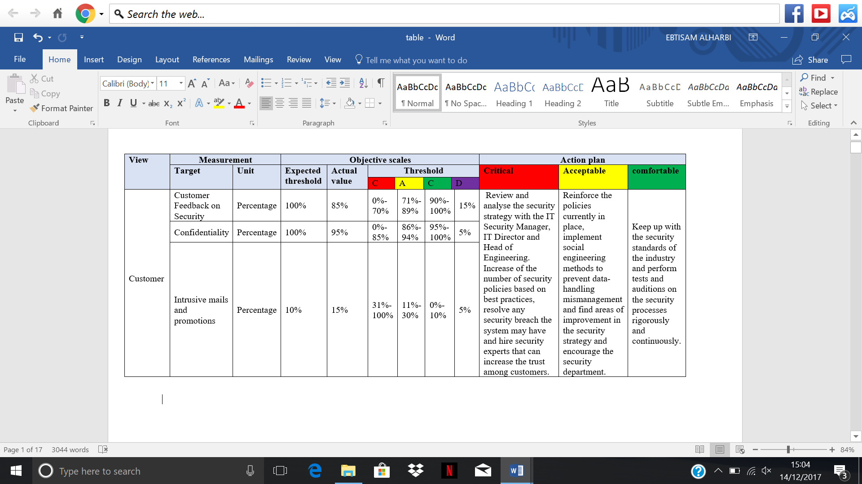

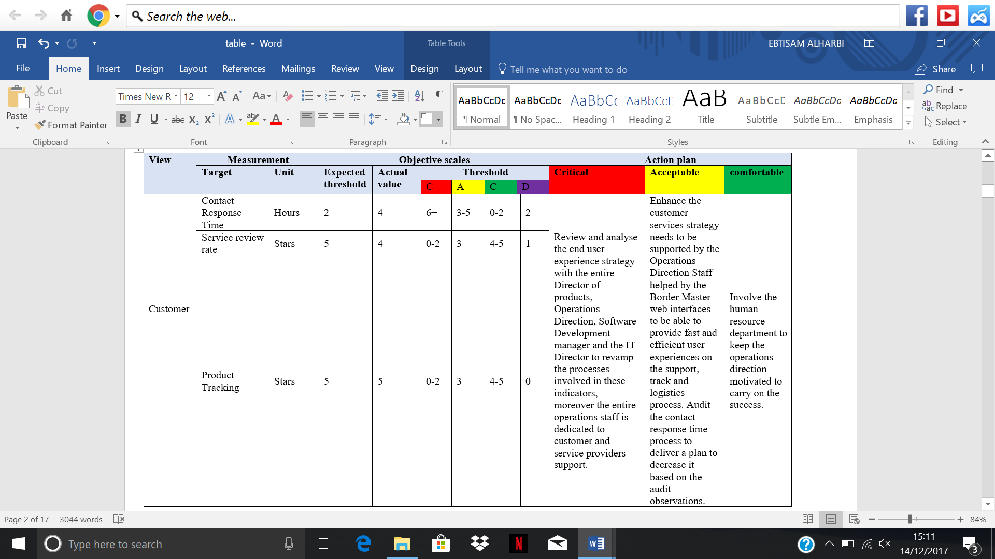

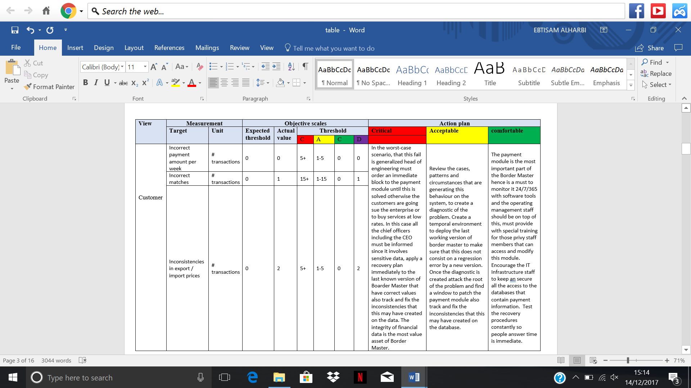

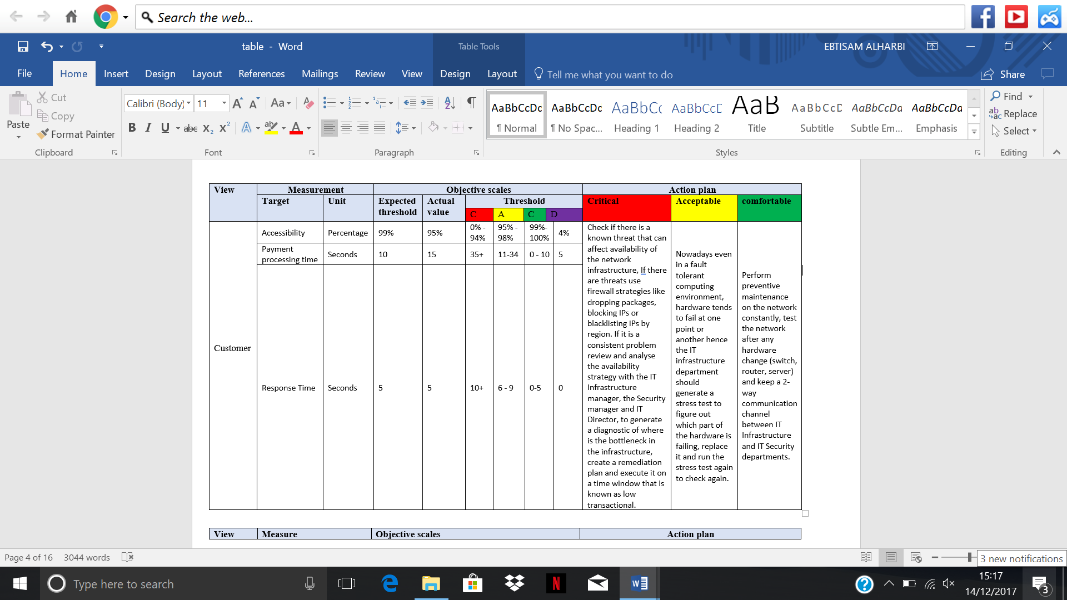

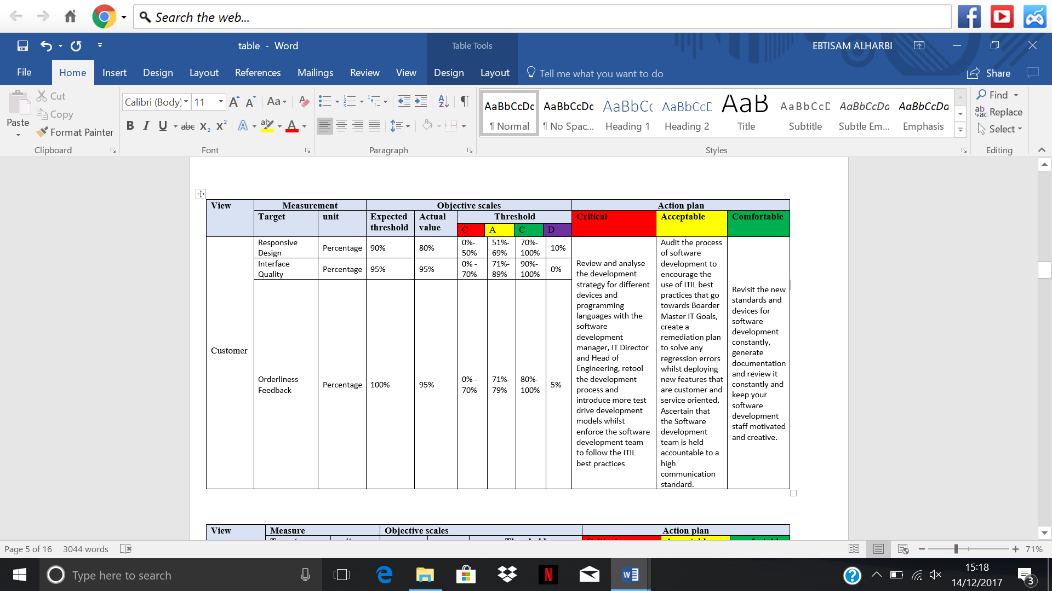

* 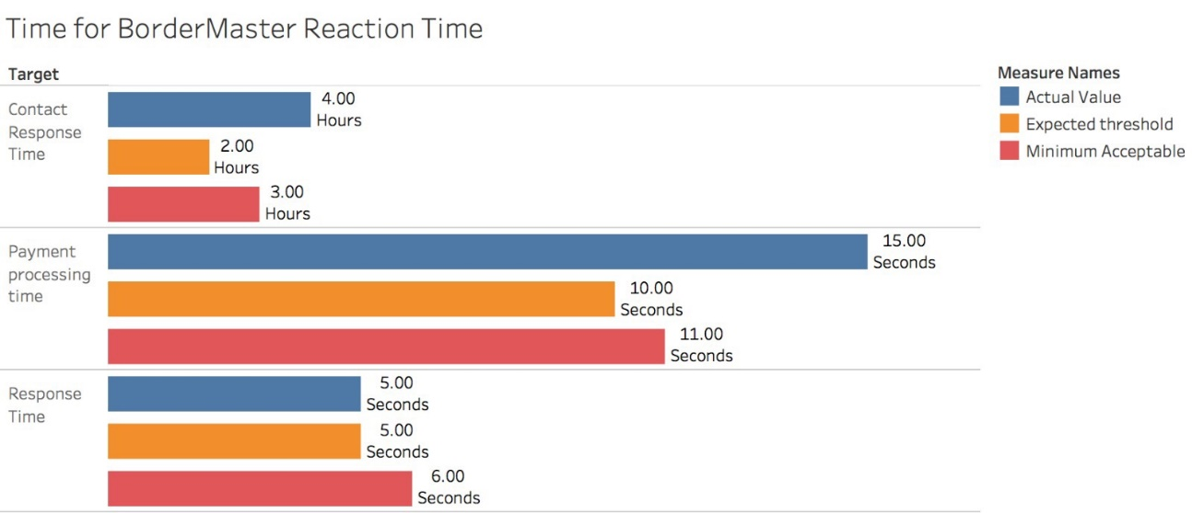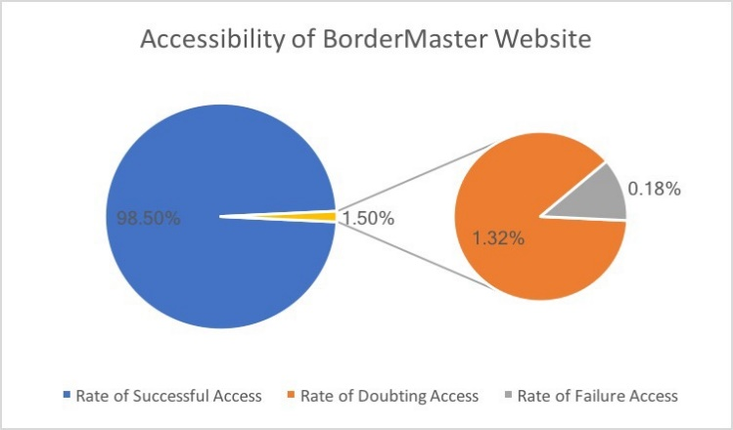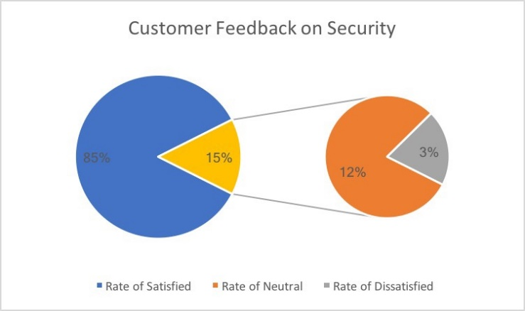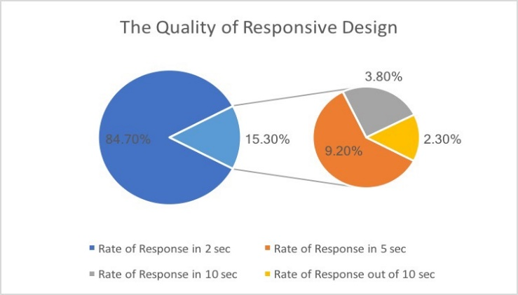**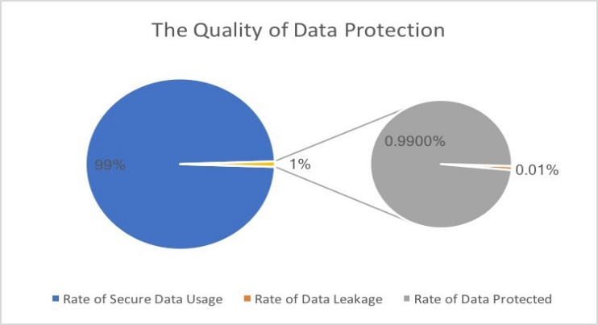The Dashboard**: figure 16 below shows the measurement of customer performance.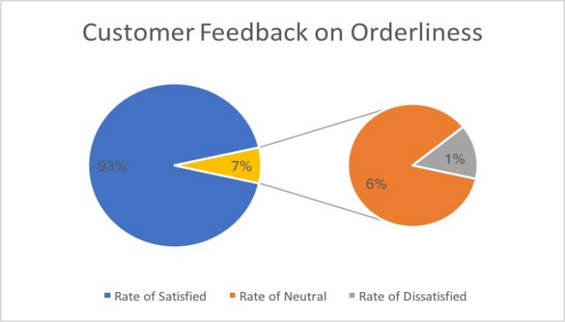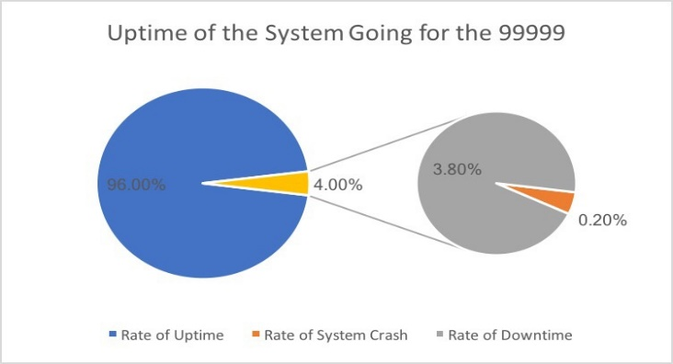

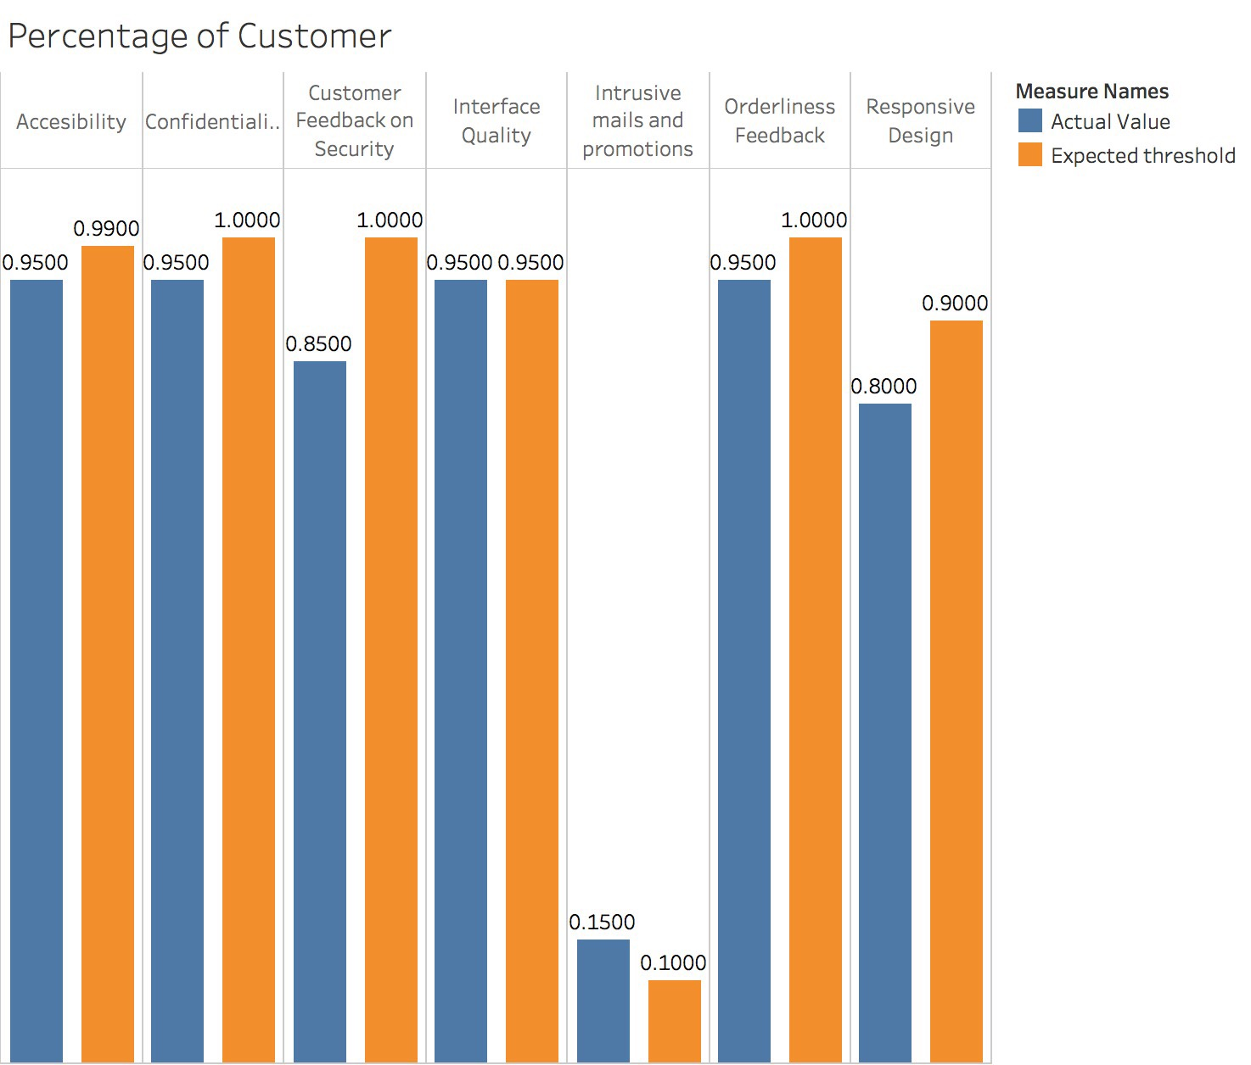

Figure 16The measurement of customer

**4.4.3Measurement of Improvement Performance**

* **The Scorecard:** table 11 below shows this measurement.

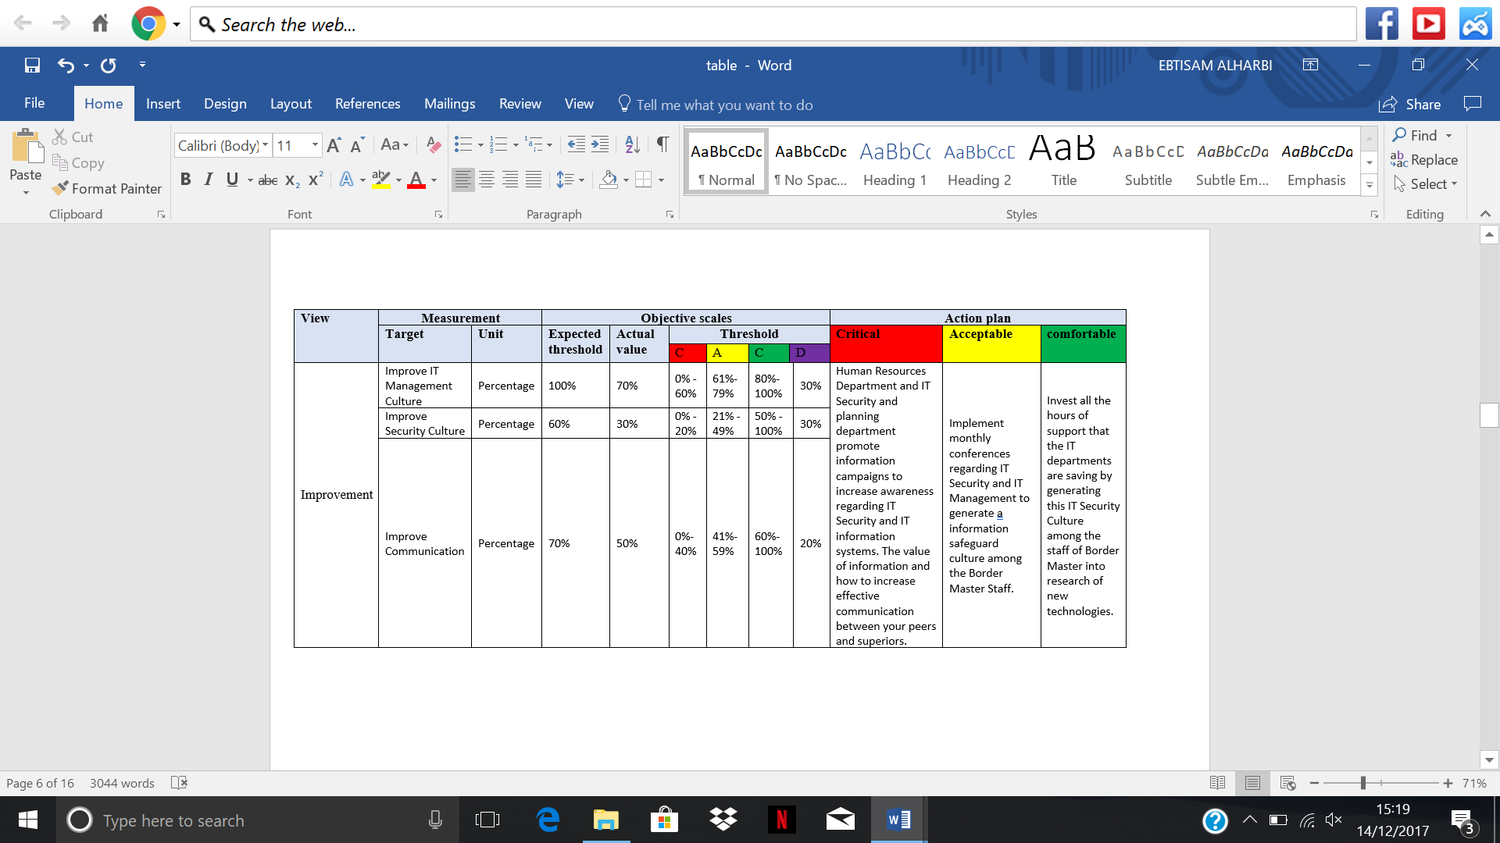

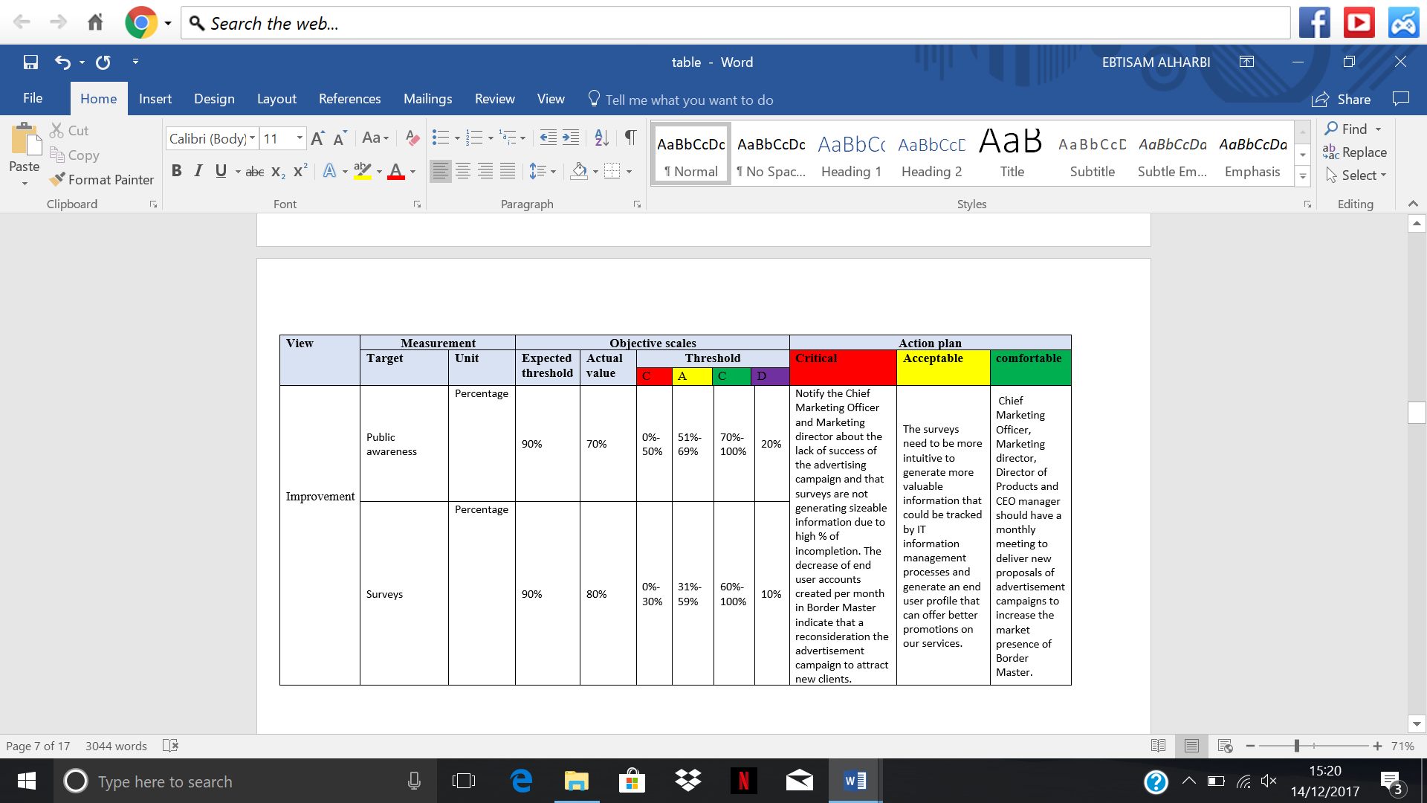

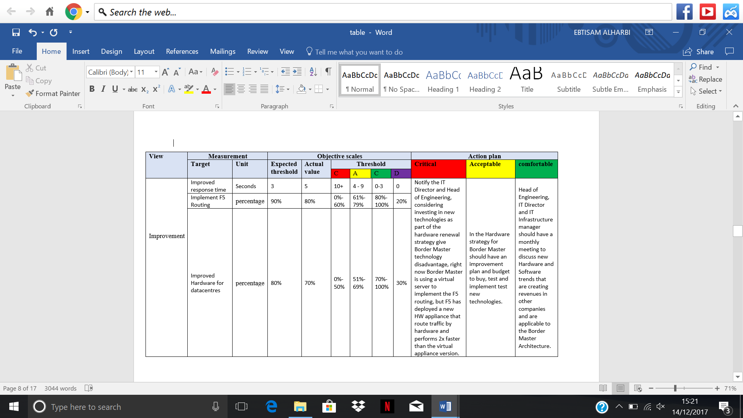

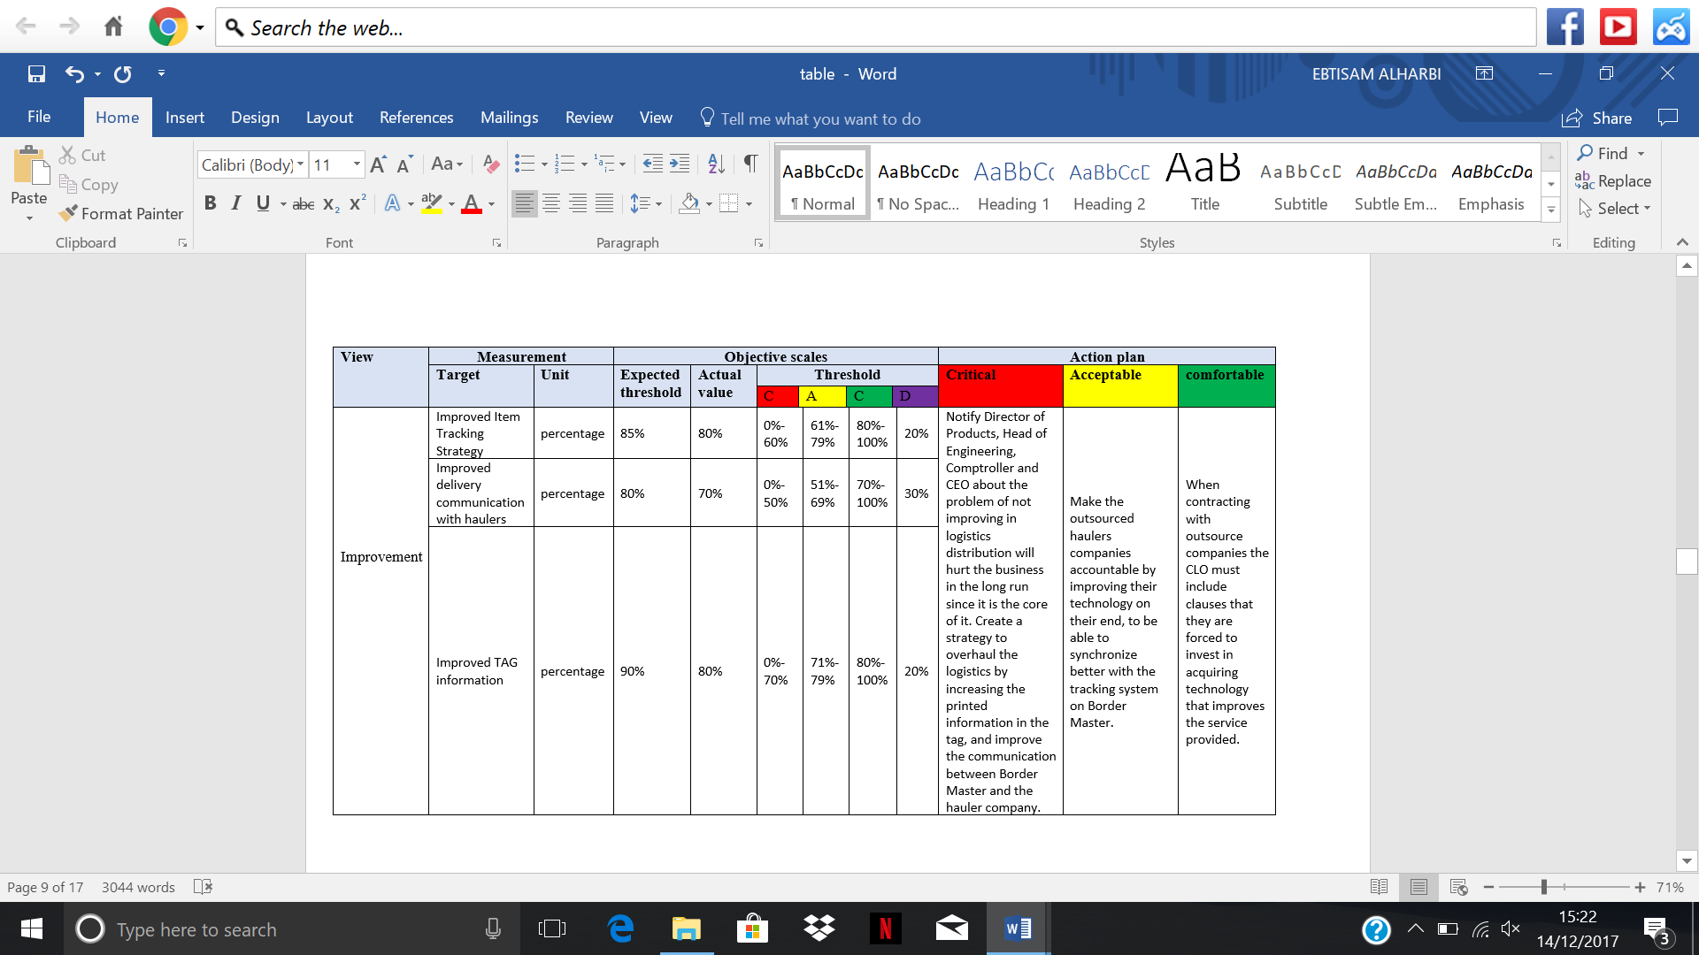

* **The Dashboard**: figure 17 below shows the measurement of the improvement Performance.

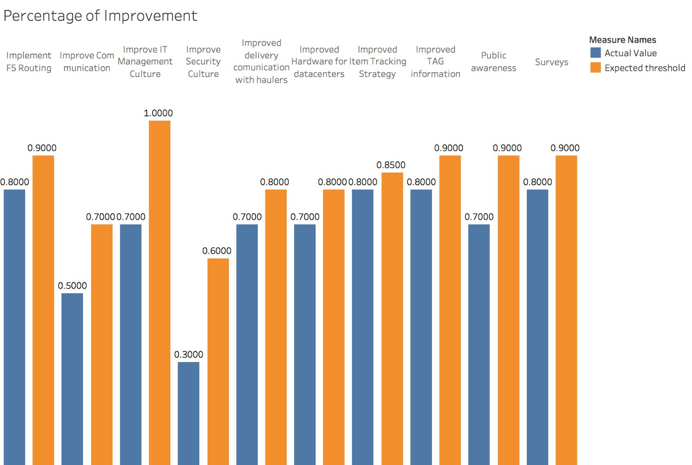

Figure 17 The measurement of the improvement Performance

**4.4.4 Measurement of Operational Performance**

* **The Scorecard:** table 13 below shows this measurement.

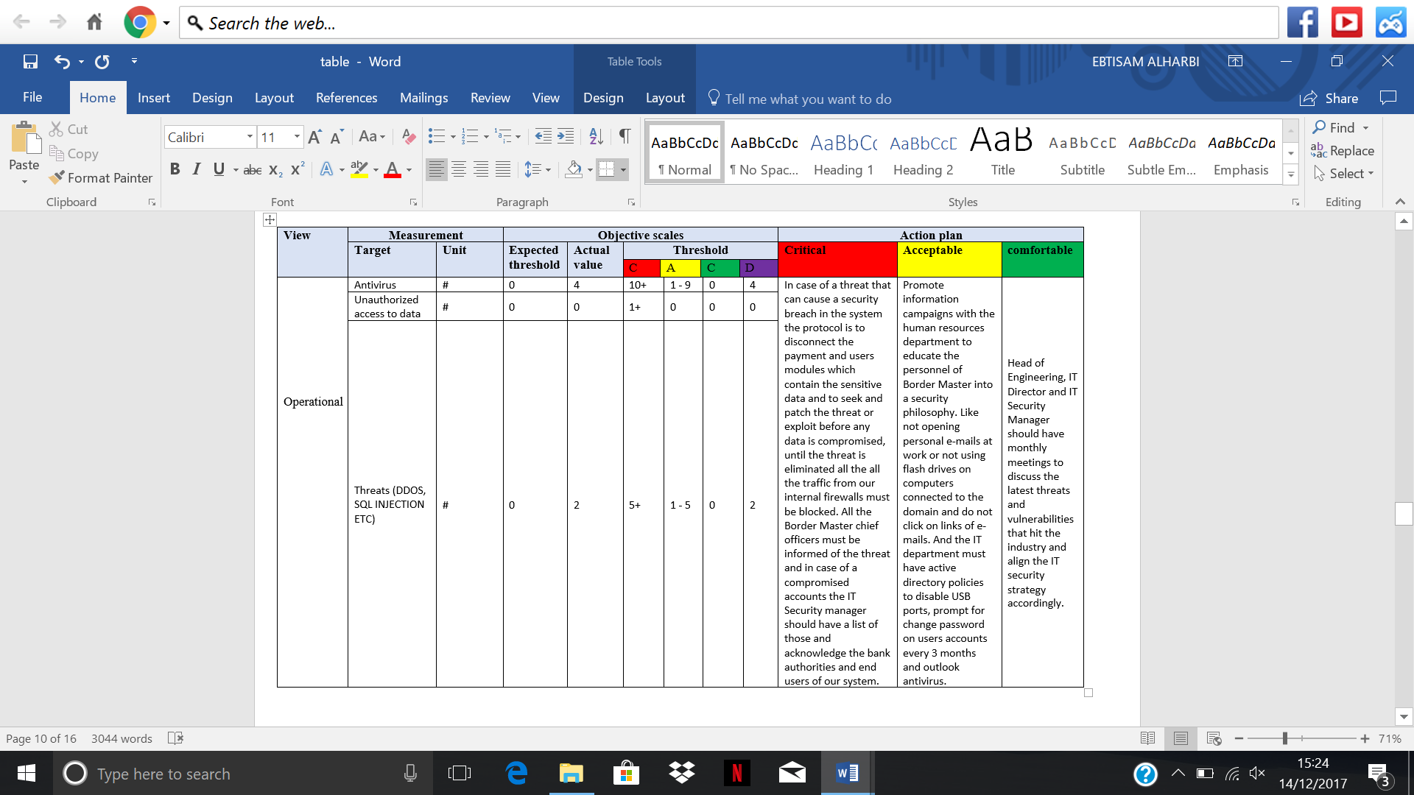

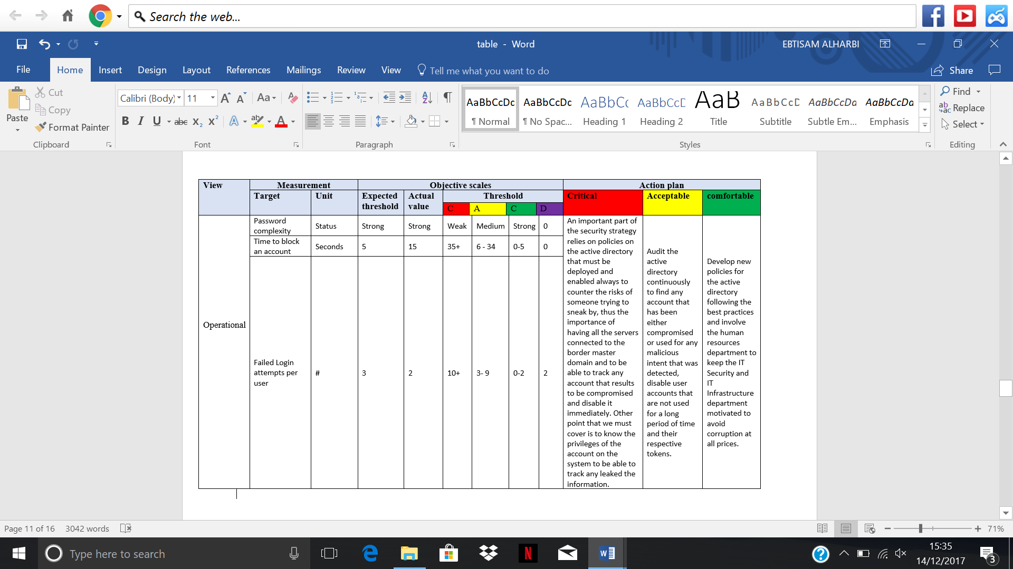

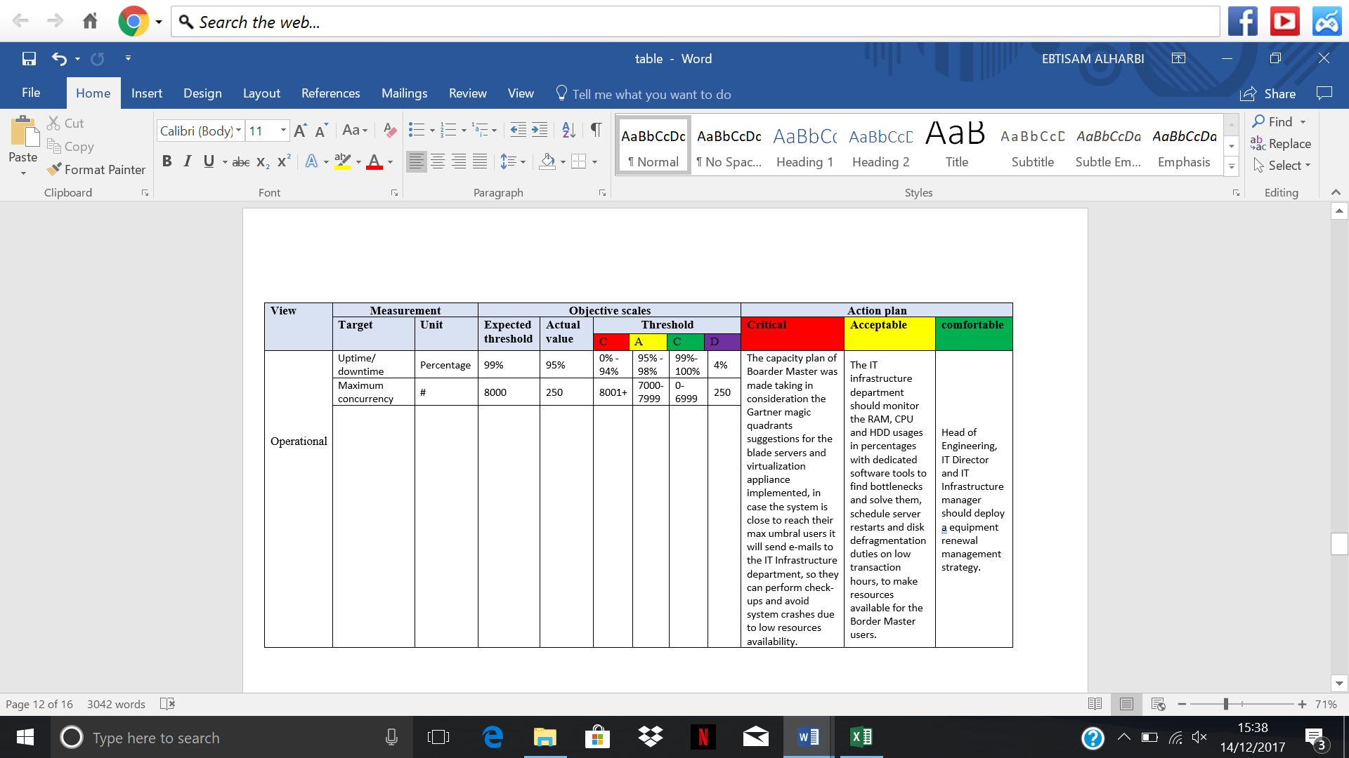

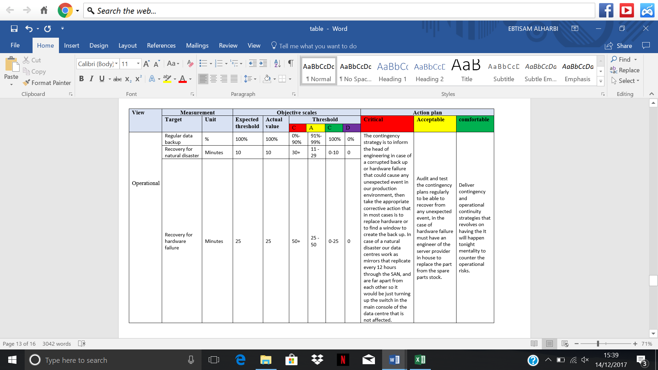

* **The Dashboard**: figure 18 below shows the measurement of Operational Performance.

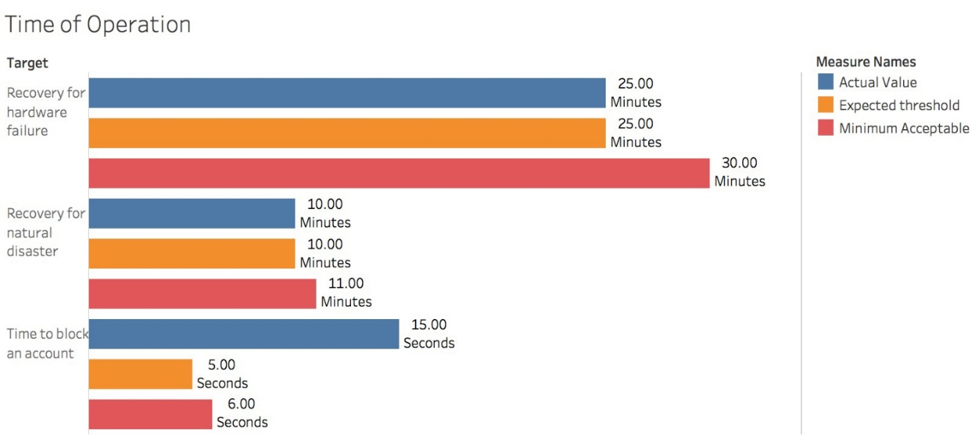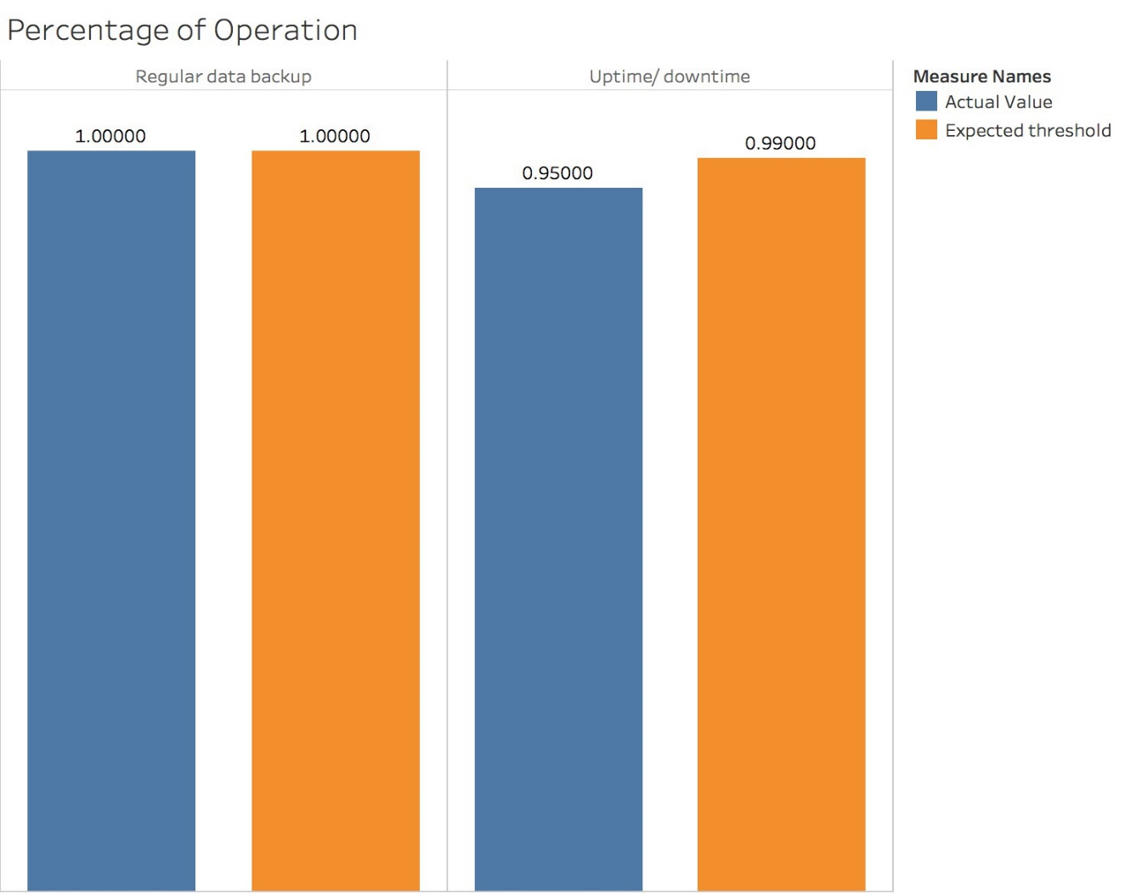

Figure 18 The measurement of Operational Performance.

**4.4.5 Measurement of Financial and risk management Performance**

* **The Scorecard:** table 14 below shows this measurement.

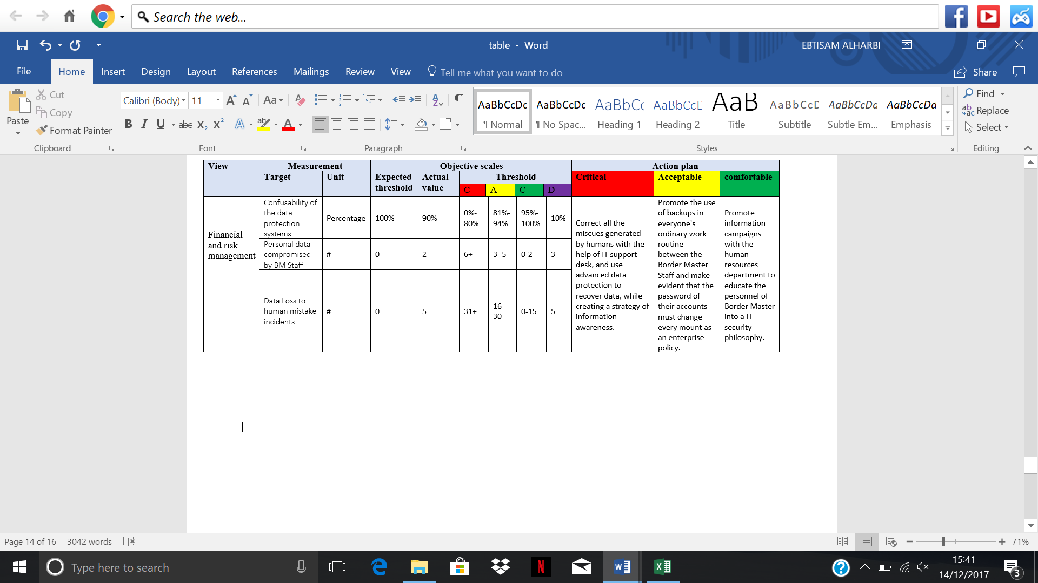

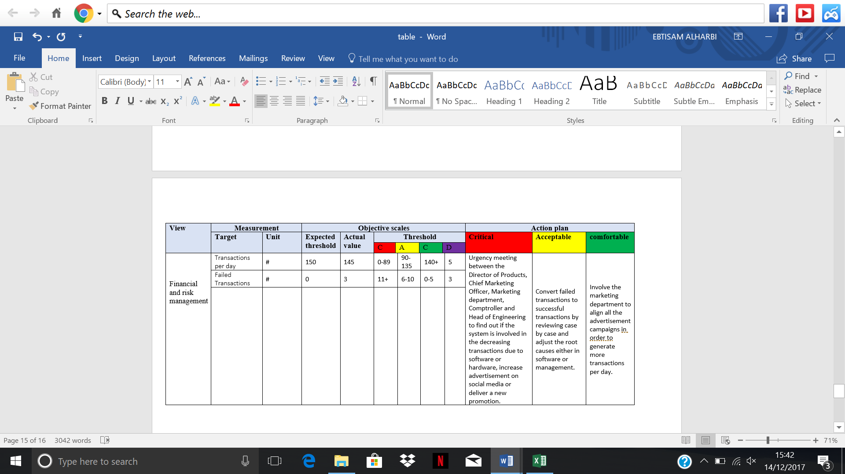

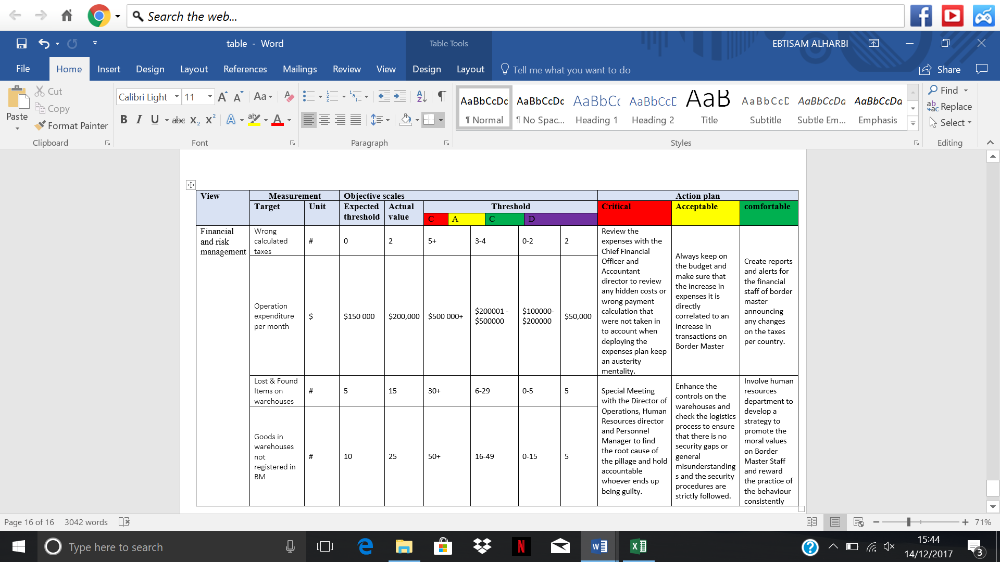

* **The Dashboard**: figure 19 below shows the measurement of Financial and risk management Performance.

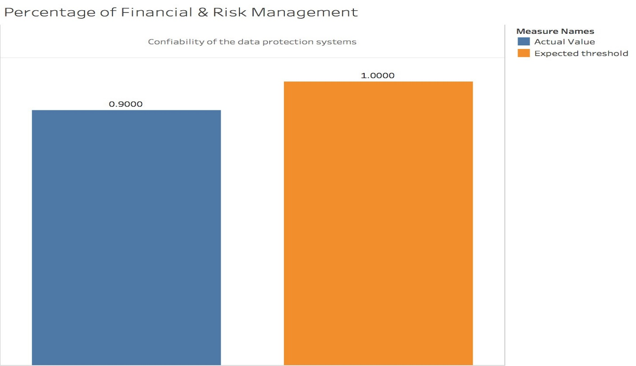

Figure 19 The measurement of Financial and risk management Performance

**Chapter 5 Conformance**

**5.1 Background**

Institutions and organizations process obligations to comply with regulatory, contractual and legal frameworks at national and international level. The non-compliance with those frameworks can result in delivering poor services under low standers; therefore, the reputation of an institution or organization will be affected negatively. In this regard, the Border Master system will require the compliance with numerous frameworks to ensure successful implementation of its objectives. This chapter will discuss, in depth, important legal frameworks that must be adopted by the management team of the Border Master to effectively meet its agenda.

**5.2 Security policy**

**5.2.1 ISO/IEC 27001**

The information security management system is an inevitable part of the general management structure to the company, and so it has a high priority to integrate it. Information security should be taken into considerations in the design procedure, network establishment, communication measures and control measures. The application of the information security management system in conformity to the requirements is expected by this standard.

Below is the standard of Border Master system according to the ISO/IEC 27001 that can be used by both internal and external parties to assess whether the ability of the company meet the demand of its own information security.

|  |  |  |
| --- | --- | --- |
| **1. Information Security Policy** | | |
| 1.1 Management Instruction for Introduction Security  Objectives: providing management Instruction and supporting information security according to the requirements of import/export and related national laws and regulations. | | |
| 1.1.1 Policies for Information Security | The Border Master leadership should establish import / export information security guidelines and submit it to the management to approve, release and deliver to all Border Master employees and suppliers, logistics, insurance and law companies. | |
| 1.1.2 Review of Information Security Policy | A review of the information security policy should be conducted by IT department staff every month or when significant circumstances occur to ensure its sustainability, adequacy, and validity. | |
| **2. Information Security Organization** | | |
| 2.1 Internal Organization  Objectives: the appropriate management framework should be established to start and control the implementation and manipulation of information security within the Border Master system. | | |
| 2.1.1 Information Security Roles and Responsibilities | Marketing department: responsible for verifying whether the business information meets the requirements of the related business management of Border Master system and notify the backstage after finding the problem in time.  Controlling department: takes charge of overall information security. Responsible for the implementation of the security of information content of Border Master system and organize contingency plans for information security.  Technical department: routine maintenance, inspection and supervision of Border Master system, ensure the information security of the front-desk.  Human Resource department: ensure the security of the personal information of all employees. | |
| 2.1.2 Separation of Duty | The Border Master staff responsible for information security report to controlling department, which takes charge of overall information security, and controlling department report directly to the CEO. | |
| 2.1.3 Contact with the Government Department | As an import and export system, the company should keep contact with the Customs Department. | |
| 2.1.4 Contact with a Particular Interest Groups | Appropriate contact with suppliers, logistics companies, law firms, banks and insurance companies should be maintained. | |
| 2.1.5 Information Security in Project Management | Whether import or export projects, information security should be integrated into project management. | |
| 2.2 Mobile Devices and Teleworking  Objectives: ensuring the safety of Border Master teleworking and mobile devices. | | |
| 2.2.1 Mobile Device Strategy | i. Devices should install the following operating systems: Android 5.5 or later, IOS 6.x or later.  ii. Devices should store all user-saved passwords in an encrypted password store.  iii. Devices should be configured with a secure password that complies with password policy of Border Master. The password should be different from any other credentials used within the company.  iv. Devices except those managed by IT department are not allowed to connect to the internal Border Master system network. | |
| 2.2.2 Teleworking | i. Border Master staff who are offered with communications equipment for teleworking in order to keep safe of sensitive information in business, should not take risk to use other less secure equipment.  ii. Teleworking equipment offered by Border Master could be revised or replaced only if  they have been authorized.  iii. Teleworking equipment offered by Border Master could only to be used by Border Master  staff.  iv. Teleworking staff should make sure the backup measures for every information took outside are applied. | |
| **3. Human Resource Security** | | |
| 3.1 Before Employment  Objectives: the human resources department should ensure that Border Master employees and contractors understand their duties and obligations, and consider that the ability of an employee is consistent with the position. | | |
| 3.1.1 Screening | The human resource department should verify the background of the verification of all appointments in accordance with the relevant legislation, regulations, morality and corresponding business requirements of Border Master. | |
| 3.1.2 Terms and Conditions for Appointment | The contract agreement between the company and the employees and contractors should provide that they ensure the safety of the information of the Border Master system. | |
| 3.2 During Employment  Objectives: Ensure that all Border Master employees and contractors have a deep understanding and fulfilling their information security obligations. | | |
| 3.2.1 Management Obligations | Make security responsibilities as part of each job description. External stakeholders such as suppliers, logistics and insurance companies should include similar descriptions within their statements of work. To Border Master staffs, this supports the commitment of the company and builds the adherence of stakeholders to the security of Border Master requirements a consideration in its service quality assessments. | |
| 3.2.2 Information Security Awareness, Education and Training | For Border Master staff in security awareness:  i. Take compulsory security awareness training courses  ii. Review Border Master information security policies and methods  iii. Contribute in common security awareness | |
| 3.2.3 Disciplinary Process | i: Staff access information without an authentic working reason and suitable permission and use the information for personal benefit.  Probable consequence: dismissal  ii: Staff access several customer information without authentic working reasons or suitable permissions.  Probable consequence: final written warning, dismissal  iii. Staff leaks sensitive business information to a recipient who has no authentic business demand for the information.  Probable consequence: final written warning, dismissal  iv. Staff access social network sites on work and leak information about the company, co-workers or clients that is sensitive or covers personal details without permission.  Probable consequence: final written warning, dismissal  v. Staff legally accepts or has access to company documents including sensitive information. He/she shares such information to a co-worker or others in Border Master without permission. The receiver does not have authentic business interest of the information and have no access to it.  Probable consequence: first written warning, final written warning | |
| 3.3 The Termination or Transfer of Employment  Obligations: ensuring that the transfer or termination of appointment does not affect the interests of Border Master company. | | |
| 3.3.1 Obligations of Termination or Transfer Employment | i. Return of company properties such as teleworking device, computer laptop, gate permits  ii. Remove all account passwords, operating records and cookies.  iii. Remove access to the Border Master network both physical and wireless connection protocols with the help of IT department.  iv. Obligations allocated especially any reflecting information security. Affected customers or suppliers and other related external stakeholders should be informed of the changes of the status.  v. The email accounts should be checked for stray emails related to customers and stakeholders. | |
| **4. Access Control** | | |
| 4.1 Business Requirements of Access Control  Objectives: access to information and information processing facilities should be limited. | | |
| 4.1.1 Access Control Policy | i. Users should access to Border Master system with authorization, and they are always restricted to recognized and permitted functions and levels of privileges. Border Master system access control should to be realized through user ID that is different from every other user to offer specific accountability. | |
| 4.1.2 The Policy of Using Network Services | i. Staff should connect to the network only from the locations that IT department has specified as connectivity positions. Terminal devices connected are limited to personal computers, notebooks, printers, and other devices.  ii. Staff should not extend the configurations of network by connecting switches, repeaters, bridges, routers, wireless access points and other devices without contacting to the IT department about their requests before.  iii. Staff should not set up mail servers without contacting to the IT department about their requests before.  iv. Staff should only use network services offered by IT department, and should not try to run network applications including Domain Name System, IP address allocation, and other management services. | |
| 4.2 User Access Management  Objectives: ensuring Border Master users access authorized systems and network services and block unauthorized access. | | |
| 4.2.1 User Registration and Cancellation | The registration and cancellation should get permission from controlling department, which can use Border Master administrator system developed and maintained by IT department to add new accounts and cancel invalid accounts. | |
| 4.2.2 User Access Configuration | The user access configuration should get permission from controlling department, which can use Border Master administrator system developed and maintained by IT department to allocate authorities. | |
| 4.2.3 Special Authority Management | The special authority configuration should get permission from controlling department, which can use Border Master administrator system developed and maintained by IT department to modify special authorities. | |
| 4.2.4 Revoking and Adjusting Access Rights | Border Master system should delete all employees' and third-party members' access to system and information processing facilities at the end of the appointment, contract, or agreement. Dynamic modification should be conducted by controlling department when information is changed. | |
| 4.3 System and Application Access Control  Objectives: Preventing Unauthorized Access to System and Applications | | |
| 4.3.1 Information Access Limitation | i. Review Border Master staff with access to security information regularly and modify privileges if needed.  ii. Restrict the amount and range of staff with administrator authorities.  iii. Offering user accounts the rights that are only vital to their work duty.  iv. Implementing extra governances over user accounts with special access authorities.  v. Individual staff should have a unique account identification number.  vi. A safe login should be required for every computer and set to be logged out automatically when absent over ten minutes.  vii. Remove access privileges of a staff at the time he/she left the company. | |
| 4.3.2 Password Management System | Password choosing: all passwords should cover at least six symbols and at least one alphabetic and one non-alphabetic character. Control characters and other non-printing characters are illegal. For setting a new password, users should provide correct identifications.  Password changing: all passwords should be promptly changed if they are suspected of being disclosed. Users are required to change passwords once in 60 days.  Password storage: passwords should not be stored in readable form without proper access control. All passwords should be sternly controlled with both physical security and computer security measures. | |
| 4.3.3 Surpassing the Use of a General Permission Application | Tools that can be used to access over-permission applications to should be strictly restricted and controlled by IT department. | |
| 4.3.4 Access Control to System Source Code | Prohibit unauthorized user access to system source code. | |
| **5. Cryptography Policies** | | |
| 5.1 Cryptographic Controls  Objectives: ensuring that the confidentiality, authenticity, and integrity of information are properly and effectively protected by cryptography. | | |
| 5.1.1 Select Appropriate Encryption Measures | Transformation Functions | Typical Encryption Algorithms |
| Encrypt and Decrypt | DES, SKIPJACK, RSA, El Gamal |
| Compute and verify MAC | DES |
| Sign and verify | RSA & hash, El Gamal & hash |
| 5.1.2 Secret Key Management | i. Safe secret key stores. Key stores should be safeguarded, during all the processes of storage, transit, and backup.  ii. Access to secret key stores. Access to secret key stores should be restricted to the objects that demand for the specific secret keys. Objects that use a certain secret key should not be the objectives that store that secret key.  iii. Secret key backup and recoverability. Safe backup and retrieval measures should be applied. | |
| **6. Physical Environmental Security** | | |
| 6.1 Security Areas  Objectives: establishing a security zone to prevent unauthorized physical access, destruction, and interference from illegitimate personnel for information processing equipment. | | |
| 6.1.1 Physical Protection Around the Security Area | The motor room should be arranged, and the security personnel are arranged to patrol. | |
| 6.1.2 Physical Entrance Controls | The security area should only arrange one entrance and arrange the inspectors to ensure that only the authorized staff can enter and exit. | |
| 6.1.3 Safety and Protection of Offices, Rooms and Facilities | Safety emergency equipment should be placed in all rooms, such as fire extinguishers, emergency packages, etc. | |
| 6.1.4 Security Protection of External and Environmental Threats | The structure of a room can withstand the damage caused by natural disasters, malicious attacks or other events, providing people with time for escape. | |
| 6.2 Equipment Security  Objectives: preventing the loss, damage, and theft of assets and equipment, and caused problems in the operation of the Border Master system and the company. | | |
| 6.2.1 Installation and Protection of Equipment | Vital equipment should be placed in a safe area to reduce the hazards caused by environmental threats as well as unauthorized access. | |
| 6.2.2 Back-up Facilities | The company should configure some spare facilities, such as standby power and standby servers, to protect important devices from accidental accidents. | |
| 6.2.3 Wiring Safety | The company should correctly design the distribution of power, cable and communication cables that transmit data or support information services to avoid eavesdropping, interferences or damages. | |
| 6.2.4 Equipment Maintenance | The company should maintain and check the equipment regularly to ensure the service life of the company. | |
| 6.2.5 Removal of Assets | Equipment, information or software is prohibited to bring out the prescribed place without authorization. | |
| 6.2.6 Equipment and Asset Safety Outside the Place of Company | Arrange two or three security personnel from controlling department to take safety measures to the wharf, warehouse and so on to reduce the risk of loss. | |
| 6.2.7 Emptying Desktop and Screen Policy | i. Staff should ‘logout’ from the terminals they use when their workplace is left untouched.  ii. Staff should ‘shut down’ the terminals they use when their duty is end.  iii. All the private and internal usage information should be cleared from the interface and sealed in a document cabinet when their workplace is left untouched or duty of staff is end.  iv. Secret keys used to access private or internal usage information should not be left at an untouched workspace.  v. Passwords should not be posted or at any other reachable places.  vi. Files covering private or internal usage data should be instantly cleared from duplicated devices. | |
| **7. Communication Security** | | |
| 7.1 Network Security Management  Objectives: ensuring that information is protected in the network and information processing facilities. | | |
| 7.1.1 Network Controls | Install a reliable firewall to ensure network security to protect the information in the system and applications. | |
| 7.1.2 Security of Network Services | The network service protocols should include all network security protocols service categories and other network security management requirements used in network communication. | |
| 7.1.3 Network Isolation | The system data and user information should be separated, not directly connected with the external network. | |
| 7.2 Security of Information Transmission  Objectives: ensuring that information will not be lost, tampered, and so on in the transmission of information. | | |
| 7.2.1 Information Transfer Policies and Procedures | i. Implement a risk assessment before transferring private Border Master information.  ii. Implement carefulness when using email to transfer private Border Master Information. Border Master staff accounts could be used to transfer only if the email is authorized.  iii. Make sure all the transfers of confidential information obey the Data Protection Act 1998.  iv. Implement the technical controls or measures required by the staff when transferring private Border Master Information.  v. Encrypt private Border Master Information prior to the transfer.  vi. Make sure private Border Master Information in accordance with the Information Security Classification Scheme. | |
| 7.2.2 Confidentiality Agreement | The company should regularly update the information that needs to be protected, and form a document of the requirements of their confidentiality agreement. | |
| **8. System Acquisition Development** | | |
| 8.1 Security Requirements of Information Systems  Objectives: ensuring that the information system is secure enough to achieve the purpose of protecting important data. | | |
| 8.1.1 Safety Requirements Investigation and Explanation | The relevant requirements of information security should be embodied in the process of establishing information systems. | |
| 8.1.2 Security of Public Network Application Service | Protect information transmitted through public networks in application services to prevent fraud, contract disputes, unapproved leaks and tampers. | |
| 8.1.3 Safety in the Transactions | i. The use of electronic signatures by each of the parties involved in the transaction.  ii. In every phase of the transaction make sure that the secret verification information of all party users is legitimate and confirmed, meanwhile the transaction should always be kept private.  iii. Communications route among all related entities should be encrypted.  iv. Communication rules among all related entities are protected.  v. The transaction details should be stored separate from every available environment.  vi. Security measures should be taken included through the complete authorization/signature management procedure in which a trusted permission is in effect.  vii. The level of the controls implemented should be corresponding to the extent of the risk related to each form of service transaction. | |
| 8.2 Security in Development  Objectives: developing a detailed safety development strategy to ensure the safe development of the system. | | |
| 8.2.1 Security Development Environment and Security Development Policy | i. The development of Border Master systems should involve sufficient consideration of: business continuity, backup and retrieval, access controls, data processing controls, extent of encryption implemented to information on transit, and documentation of security approaches, suitability of offsite storing for backup.  ii. Applying recognized controls for development processes.  iii. Make sure only legitimate and correct data can be processed during programming.  iv. Audit department should be informed at the start of the Border Master system development to make sure that the demand control structure be applied as a part during early development process.  v. Error-checking, bug-checking and malware-checking should be conducted to the whole programming code using industry standard antivirus testing measures.  vi. Functional testing should be conducted during the development of Border Master to make sure that procedures perform as anticipated and meet with criteria.  vii. Measures to backup and protect information against damage or loss should be considered.  viii. Backup policies and business continuity plans should be involved into the Border Master development plan.  ix. Disaster recovery actions should be considered to recover systems, data, applications.  x. Suitable assurance of obtainability should be offered and recognized at the beginning of the development lifecycle.  xi. Make sure compliance with any legitimate, constitutional and legal requirements during the whole development lifecycle.  xii. Make sure the security of communications implementing recognized, latest security protocols and standards related to the communication techniques applied.  xiii. Modifications in the development lifecycle should be measured by the application of formal change control processes to make sure the safety and integrity of Border Master system information.  xiv. Effective reporting mechanisms should be built and facilitated for Border Master system achieving audit department requests for reporting that involve system access, networks and client terminals access details.  xv. Successive maintenance of developed Border Master systems should maintain the system integrity and the original security except the maintenance is demand because of recognized security risks or vulnerabilities.  xvi. Version control for development should be applied to recognize the phases of the development lifecycle to mitigate risks related with improper code application and documentation. | |
| 8.2.2 Outsourcing Development | Send the professional personnel to conduct the security inspection and function examination to ensure its applicability. | |
| 8.2.3 System Security Test | When developing an information system, the company should often test the security of the system. | |
| 8.2.4 System Update Test | Test the security of the new system during system updates and version upgrades. | |
| 8.2.5 Protect the Data Used in Testing | Carefully select, protect and control the test data to facilitate the development and updating of Border Master system. | |
| **9. Supplier Relationship Policies** | | |
| 9.1 Security in Supplier Relationship  Objectives: ensuring that the information accessed by the vendor is safe to avoid unnecessary errors and losses. | | |
| 9.1.1 Information security policy for supplier relationships | i. Concentrate on minimalizing the risk in the import / export area, apply risk mitigation part of the negotiation and contract service-level agreement.  ii. Work closely with the supplier to recognize and resolve problems to reduce the risk.  iii. Assess the supplier before contract renewal or more regularly; implement particularly evaluations when distresses arise.  iv. Collect information outside about the supplier.  v. Measures applied to the supplier’s performance through the time of the relationship with Border Master. | |
| 9.1.2 Addressing Security within Supplier Agreements | If information security problems arise, the company should send professionals to deal with them and establish and negotiate new information security requirements with suppliers. | |
| 9.1.3 Product Supply Safety | The supplier should ensure that the supply of the product is safe and will not cause the loss of the company's interests. | |
| 9.2 Supplier Transaction Management  Objectives: ensuring the safety of information and properties in the transactions and should be consistent with the agreement. | | |
| 9.2.1 Monitoring and Review of Vendor Services | Send professionals to supervise the standard trading of suppliers. | |
| 9.2.2 The Strategy of Changing the Service Provider | Regularly improve services of suppliers, including maintaining and improving existing information security policies, procedures and control measures, and taking into account of risk assessment during import and export. | |

**5.1.2 Payment Card Industry Data Security Standard (PCI DSS)**

PCIDSS consists of six parts, namely firewall implementation and configuration policy (security construction data environment), cardholder data protection (through data encryption to improve data storage and transmission security), malware protection policy (software and software development of safety supervision and the loopholes in the system), data access control policy, regular monitoring and testing network (tracking access to data, regular testing of all safety measures) and the maintenance of information security policy (the staff data protection responsibilities).

The first part is to establish and maintain a secure network and system. According to the network diagram and data flow diagram, record of service, protocol and port, reference firewall configuration requirements to build a firewall and router connection limit data and network environment, and prohibit direct public access between the Internet and the components of the system, even if it is used in the network of personal equipment it still need unified installed personal firewall software. Secondly, always change the default value supplied by the vendor, disable or delete the default account, set up the configuration standard for all the system components, and encrypt all the non-console access with SSH, VPN or SSL/TLS technology.

|  |  |
| --- | --- |
| **Requirement 1: IT department in Border Master should install and maintain firewall configuration to protect cardholder data (control the flow of data flow into the outflow).** | |
| 1.1  IT department  establish the implementation of the configuration standard | i. The designer of the IT Department checks written programs which are used to set up firewall configuration, including network connections and change records. |
| ii. The designer of the IT Department checks the network chart and network configuration. |
| iii. The designer of the IT Department checks the data flow chart (the location of storage, processing, or transmission of data). |
| iv. Firewall configuration personnel checks firewall configuration standards. |
| v. The person who is responsible for network component arranges Installation work. |
| vi. Document manager of the Department documents records of all services, protocols, and ports. |
| vii. IT personnel regularly reviews the firewall router rules set. |
| 1.2  IT department  build firewall and router configuration | i. limits the input and output to the required range. |
| ii. Document manager of the Department protects and synchronizes the router configuration file (reboot the router rules). |
| iii. Professional installation team installs the peripheral firewall. |
| 1.3  prohibition of direct access to the Internet | i. IT department implements DMZ (Demilitarized Zone, is commonly known as the demilitarized zone, the role of the WEB, E-mail, etc., to allow external access server connected to the port area alone, the need to protect the internal network connected to the trust zone port, do not allow any access, realize the internal and external network isolation, meet user’s demand). |
| ii. IT department employees check firewalls and routers and input Internet flow only to the IP addresses within DMZ. |
| iii. IT department employees prohibit direct access to Internet traffic. |
| iv. IT department employees perform anti deception measures to prevent forged IP input flow. |
| v. prohibits unauthorized flow output to the Internet. |
| vi. IT department employees do state check (only an established connection can enter the network). |
| vii. IT department place sensitive data in an isolated internal network. |
| viii. do not disclose private IP addresses and routing information to non-authorized parties (IT department will use network address conversion (NAT) and proxy servers to cover up IP addresses to prevent hackers using internal IP address access.) |
| 1.4 A personal firewall is installed on the staff equipment to connect to the Internet (protect devices against network attacks. Devices that connect to the intranet should be well protected both inside and outside of company, with specific configuration settings and cannot change by device users). | |
| 1.5 Border Master management ensure that each department of Border Master company understand the security policies and operating procedures of the firewall management. | |
| **Requirement 2: IT department should not use the default system password and other security parameters provided by the vendor.** | |
| 2.1  IT Department always change the default value of the vendor and delete or disable the unnecessary default account | i. For a wireless environment that can be connected to the cardholder's data environment, the default value of the wireless vendor is changed at the time of installation. |
| 2.2  IT department sets up configuration standards suitable for all system components | i. Each server performs only one major function to prevent a server from requiring different security levels (with virtualization technology, check the system configuration, confirm that each virtual system component only performs a major function). |
| ii. Only starts the necessary services, protocols, daemons, and so on. |
| iii. IT department performs additional security functions like SSH and S-FTP for unsafe services, protocols, and daemons. |
| iv. IT department configures system security parameters. |
| v. IT department removes all unnecessary functions (including scripts, drivers, features, subsystems, features, file systems, etc.), reducing the risk of unknown functions being utilized. |
| 2.3 Uses SSH, VPN, and SSL/TLS technology method to encrypt all non-console management access | |
| 2.4 Document manager of the Department keeps the list of hardware and software components within the range of PCI DSS. | |
| 2.5 IT department manager ensures the employees in IT department understand the relevant settings | |

The second part, the protection of cardholder data. The data secrecy is realized in two aspects of data storage and data transmission. The first implementation of data retention and processing policy, to minimize the storage of data and meanwhile to make sensitive data encryption unreadable, at the same time conduct secret key management. In the process of data transmission, strong encryption and security protocols are used to protect the data.

|  |  |
| --- | --- |
| **Requirement 3: Protecting stored card holder data** | |
| 3.1 Management minimize the amount of storage and storage time of the cardholder | |
| 3.2  After authorization, it is confirmed that all sensitive verification data are not recoverable (to prevent the generation of counterfeit payment cards) | i. Do not store the full contents of any track on the back of the memory cards or the chips |
| ii. Do not store the card verification code or value used to confirm the non-real card transaction |
| iii. Do not store personal identification code (PIN) or encrypted PIN data blocks |
| 3.3 Concealment of the main account information (computer screen, receipt, paper report, etc.) | |
| 3.4 The main account information in all locations (portable digital media, backup media, log, etc.) is not readable. | |
| 3.5  IT department use encryption key and key management for encrypting the data encryption key | i. Limited only a few custodians have access. |
| ii. The key for encryption key and the data encryption key are placed in the security encryption devices separately. |
| iii. Reduces the place of key storage. |
| 3.6  Data encryption key management | i. Generate strong keys. |
| ii. Security key distribution. |
| iii. Secure key storage. |
| iv. Replace the key at the end of the key period. |
| v. Replacing the password when the key period is weak, or the password is threatened. |
| vi. If we use manual plaintext key management operation, we must manage these operations by partitioning knowledge (at least two persons control the consist of keys) and dual control (the authentication materials of two persons are needed to conduct key management operation). |
| vii. prevent key unauthorized replacement. |
| viii. key keeper correctly understands the requirements. |
| 3.7 Management ensures all the concerned employees know all the policies and operations. | |
| **Requirement 4: encryption of card holder data transmission in open public network.** | |
| 4.1 IT department use SSL/TLS, IPSEC, and SSH to encryption, including: only accept trusted keys and certificates, the protocols used only support secure versions or configurations, and encryption strength is suitable for the encryption methods used. | |
| 4.2 IT department does not use end-user communication technology to transmit unprotected PAN. | |
| 4.3 Management ensures that all the concerned employees understand all security policies and operating procedures. | |

The third part is to maintain the vulnerability management plan. The antivirus software is deployed, and the antivirus mechanism is maintained. The system constantly updates security vulnerabilities, constantly update security patches, and note that there are no software vulnerabilities in the process of software development, so that development, testing and production environments are separated from each other.

|  |  |
| --- | --- |
| **Requirement 5: IT department provide malware protection for all systems and regularly update antivirus software or programs.** | |
| 5.1  IT department deploy Norton antivirus software in a system affected by malware | i. Ensure that antivirus programs can detect, delete, and prevent all known types of malware. |
| ii. For systems that are not affected by malware, it is necessary to assess the threat of malware regularly to confirm the demand to use antivirus software. |
| 5.2 IT department employees ensure the maintenance of antivirus mechanisms: keep up to date, perform regular scans, and generate check logs. | |
| 5.3 Only managers can disable or change user equipment. | |
| 5.4 Management ensures that all the concerned employees understand the security policy and operating procedures. | |
| **Requirement 6: IT department develop and maintain a secure system and application** | |
| 6.1 IT department manager develops related processes, use external sources to acquire security vulnerabilities to identify security vulnerabilities and level | |
| 6.2 IT department installs a security patch to ensure that all system components eliminate known vulnerabilities | |
| 6.3  Software applications meet PCI DSS, based on industry standards, information security is integrated into the entire life cycle of software development | i. IT department removes development, test, and custom accounts, user ID, and password before the application is started. |
| ii. IT department identify potential bugs before publishing the product (conforming to safety code Guide). |
| 6.4  Changes in the system components must comply with the change control process and program | i. The development / test environment is independent of the production environment, and access control is built to ensure the separation of the two environments (prevent the introduction of malicious code, and the leakage of data). |
| ii. The separation of responsibilities between development and testing environment and production environment (developers have administrator accounts in development environment, but there are only user level independent accounts in production environment). |
| iii. Real data is not used during the test and development process. |
| iv. Before the production system starts, IT department deletes the test data and accounts. |
| v. The change control application security patches and software modifications must include the followings: influence of recording, the approval records changed by authorized party, function test (to confirm the effects of the change on the security of the system), cancel the program (if the change is failure, need to cancel the program to restore the previous state system). |
| 6.5  IT department use the security coding technology to solve the coding vulnerability in the software development process | i. Injection attack (parameterized query, input validation) |
| ii. Buffer overflow (verify the boundary of the buffer zone and intercept the input string) |
| iii. Non-secure encrypted storage (powerful encryption) |
| iv. Non-secure communication (verification and encryption coding technology) |
| v. Incorrect error handling (error response does not reveal special information, return to general rather than specific error details) |
| vi. Identify all high-risk vulnerabilities in the vulnerability identification processes (confirm that high-risk vulnerabilities are found and solved during development) |
| vii. Cross site scripting (XSS, parameter validation, using context related escape) |
| viii. Incorrect access control (unsafe direct object reference, failure to limit URL access, etc.) |
| ix. Cross Site Request Forgery (CSRF) |
| x. Failure verification and session management |
| 6.6 For public oriented web applications, IT department conducts periodic assessment and audit, and continuous solutions to new threats and vulnerabilities | |

In the fourth part, Border Master system should implement strong effective access control measures. It is divided into restrictions on the access to data, and through the operation data access process can be tracked back to the individuals, and the physical access should be monitored. First, staff only be authorized to access to the minimum amount of data and permissions necessary for executing tasks, assign unique identifiers to each person with access rights and have reasonable user authentication management. Using the camera and access control mechanism to monitor the physical access to the sensitive area and protect the physical security of all the media.

|  |  |  |
| --- | --- | --- |
| **Requirement 7: limit access to cardholder data in accordance with business informed demand** | | |
| 7.1  Only individuals with working demand can access system components and cardholder data | | i. Define access requests for each employee (access to resources). |
| ii. Limit the user access permissions to the required minimum permissions. |
| iii. Allocate access authority based on work categorization and function, for example, supplier users can only access web pages for the supply of goods. |
| iv. Management determine that the allocation permissions have written records and approval documents, and the writing permissions match the roles. |
| 7.2 IT department establish access control system for system components, restrict access according to user inform demands, "refuse all" in default. | | |
| 7.3 Management ensure that relevant employees understand the relevant security policies and operating procedures. | | |
| **Requirement 8: identify and verify access to the system components** | | |
| 8.1  Non-consumer users and administrators perform user identification management in the system | i. Allocation unique ID. | |
| ii. Control all changes to the user ID and other authentication credentials. | |
| iii. User access rights revoke immediately once expired. | |
| iv. Remove / disable an inactive user account at least every 90 days (not commonly used accounts are often targets to attack because users do not notice changes in the account). | |
| v. The user ID that the vendor uses to remote access, support, or maintain the system is monitored during use and is enabled only in the time required. | |
| vi. Limit repeated-attempt accesses, lock user ID after no more than 6 invalid login attempts. | |
| vii. Set lock time to at least 30 minutes, or until the administrator has enabled the ID. | |
| viii. Set system / session idle-timeout function to no more than 15 minutes. | |
| 8.2  In addition to distributing the unique ID, IT department use password, token devices, smart cards, personal characteristics (biometrics, etc.) to authenticate users | i. IT department use RSA encryption algorithm to make all authentication certificates unreadable in both transmission and storage. | |
| ii. Modified authentication credentials (password reset, generate new keys or provide new tokens) before authentication. | |
| iii. Password conforms to at least 7 characters and contains both numeric and alphabetic characters. | |
| iv. Change the password once at least 90 days. | |
| v. Submitting a new password is not allowed to be the same as the last 4 passwords. | |
| vi. First password and reset password of each user are unique and should be changed immediately after the first use. | |
| 8.3 Token authentication, Remote Authentication Dial-In User Service (RADIUS), and Terminal Access Controller Access Control System (TACACS) is used for remote access. | | |
| 8.4 File administrator record and deliver a guide to the selection of strong validation vouchers, validation procedures and policies to users. | | |
| 8.5 Do not use regular user ID, do not use shared user ID for system management, and use to manage system components. | | |
| 8.6 System login uses physical or logical security tokens, smart cards and certificates and other verification mechanisms, the verification mechanism must be unique and not shared, and has physical / logical control. | | |
| 8.7 Access to any database is forbidden. User's operation on database is done by programming. Only database administrators can directly access or query database. | | |
| 8.8 Management ensure that relevant employees and users understand the relevant security policies and operating procedures. | | |
| **Requirement 9: restrict physical access to cardholder data** | | |
| 9.1  Supervision department the control of the entrance of the place to restrict and monitor the physical access of the system in the data environment of the cardholder | | i. Use a camera or / and access control mechanism to check the data collected to be associated with other items, at least store for three months. |
| ii. Implement physical and / or logical control to restrict access to public network socket switches. |
| iii. Limit physical access to wireless access points, gateways, handheld devices, network / communication hardware and telecommunication lines. |
| 9.2 Management develop related procedures, identify staff and visitors: identify new personnel, modify requirements, cancel ID cards of staff and expired visitors. | | |
| 9.3 Supervision department control physical access of the on-site staff to the sensitive area, get the right of use according to the work function, and Human Resource department immediately withdraw the right to use and return all physical access mechanisms (keys, access cards, etc.) once leaving. | | |
| 9.4  Relevant procedures identify and approve visitors | | i. Before entering, it needs approval by supervision department and should be accompanied when entering the area of processing or maintaining the data of cardholders. |
| ii. Send out identity documents to visitors after identifying visitors. |
| iii. Visitors return their identity documents before the date of expiration or the place of departure. |
| iv. File administrator uses a visitor log and reserve the log for at least three months. |
| 9.5 Protect all media’s physical safety (computers, mobile electronic media, paper receipts, paper reports, etc.), backup media are stored in safety, preferably outside locations, at least once a year to check the safety of sites. | | |
| 9.6  Strictly control the internal or external distribution of the media | | i. Identifying the media that contains sensitive data. |
| ii. Delivery media can be delivered by accurately tracked delivery. |
| iii. When the media is transferred, it is confirmed that it is approved by the management. |
| 9.7 Control the access to the media, and IT department maintain the inventory record of the media, at least check once a year (to prevent theft or loss). | | |
| 9.8  The media should be destroyed when the media is no longer needed | | i. When the media is destroyed, hard copy materials are crushed, incineration or beating to ensure that the card's data cannot be rebuilt. |
| ii. The cardholder data on the electronic media are deleted from the industry approved security erasure standard, to ensure that the card's data cannot be rebuilt. |
| 9.9 Management ensure that relevant employees and visitors understand the relevant safety policies and operating procedures. | | |

In the fifth part, regularly conduct monitoring and testing of the network. The system components implement automatic check records, periodically review logs and security events. Periodically conduct vulnerability scanning, periodic implementation of penetration testing, intrusion detection prevention.

|  |  |
| --- | --- |
| **Requirement 10: track and monitor all access to network resources and cardholder data** | |
| 10.1 IT department implement a check record and link all access to the system component to the individual user | |
| 10.2  IT department implement automatically check to all system components to rebuild the listed events | i. Access to all personal users of the card holder's data (identification of a threat or misused account). |
| ii. Any operation that is performed by an individual with root or administrator privileges (higher privileged accounts have a greater impact on the security or operating function of the system). |
| iii. Access to all check records (malicious users may be able to mask their operations by changing the check log). |
| iv. Invalid logical access attempts (multiple invalid login attempts can explain unauthorized users trying to enforce or guess the password). |
| v. The change of the use of the identification and validation mechanisms and all changes, additions, or deletions of the root or administrator privileged account (identifying the operating user at the time of the event). |
| vi. Check the initialization, closing, or pause of the log (a masking measure of a malicious user). |
| vii. Creation and deletion of system level objects. |
| 10.3 For each event, log entries include at least: user identification, event type, time, success or failure prompt, cause and related items. | |
| 10.4  IT department uses time synchronization technology (network time protocol, NTP) to synchronize all key systems' clock and time, and ensure that the listed items are implemented to obtain, allocate and store time | i. The key system time is correct and consistent. |
| ii. Time data is protected. |
| iii. Time sets come from the time sources approved by the industry. |
| 10.5  Supervision department protects the inspection record and prohibit the change | i. Only the persons with work demand look at the checkout record. |
| ii. Prevent unauthorized modification of check files by access control, physical isolation, or / and network isolation. |
| iii. Immediately backup the check record file to the hard to change central log server or medium. |
| iv. Write out the logs of the outside technology (wireless, firewall, DNS, mail) to the secure internal central log server or media device. |
| v. The log integrity monitoring or change detection software is used for the log. |
| 10.6  Supervision department audits log and security events of all system components to identify exceptions or suspicious circumstances | i. Audit at least once the following every day: all security incidents (notice or warning after discovering suspicious or abnormal activities), security log, system log from the key components, the log from the implementation of security function (firewall, IDS/IPS). |
| ii. Regular audit of the log of other system components. |
| iii. Follow up the exceptions and exceptions found in the audit process. |
| 10.7 File administrator reserve the history of the inspection record for at least one year. | |
| 10.8 Management ensures that relevant employees understand the relevant safety policies and operating procedures. | |
| **Requirement 11: IT department regularly tests safety systems and processes** | |
| 11.1  IT department test whether there is a wireless access point and detect and identify all authorized and unauthorized wireless access points on a quarterly basis | i. File administrator keeps an authorized list of wireless access points, including business reasons. |
| ii. If an unauthorized wireless access point is detected, an accident response program is implemented by IT department, refusing its access to system. |
| 11.2  IT department at least each quarter runs an internal and external network vulnerability scanning, and runs a vulnerability scan when the network has significant changes | i. Every quarterly internal vulnerability scan is implemented by IT department until all high-risk vulnerabilities are solved. |
| ii. The authorized scanning vendor (ASV) authorized by the PCI DSS performs the quarterly external vulnerability scanning until the scan is passed. |
| iii. In the event of an important change, the scan is required as the situation needs to be performed. |
| 11.3  IT department implement the penetration test method: (the purpose is to simulate the attack in the real world, to understand the extent to which the attacker can penetrate the environment) | i. IT department performs an external penetration test at least once a year, and perform tests on an important change in the infrastructure or application. |
| ii. The internal penetration test is also at least once a year. |
| iii. The vulnerabilities found in the penetration test have been repaired and fixed by repeated execution tests. |
| iv. If the network segmentation is used to isolate CDE from other networks, at least once a year, a penetration test is performed to confirm whether the segmentation method is valid. |
| 11.4 IT department uses intrusion detection and / or intrusion prevention technology to detect and / or defend network intrusion and monitor the flow in the data environment. | |
| 11.5 Supervision department deploys change detection mechanism (such as file integrity monitoring), alert staff when finding unauthorized changes in important files, at least once a week, compare important documents. | |
| 11.6 Management ensures the relevant employees understand the relevant safety policies and procedures. | |

The sixth part is to maintain the policy of information security. Staff should be aware of data sensitivity and responsibility for protecting these data.

|  |  |
| --- | --- |
| **Requirement 12: Human Resource department maintain the information security policy for all staff** | |
| 12.1 Human Resource department formulates, publishes, maintains and publicizes security policies, review at least one security policy every year, and update it when the environment changes. | |
| 12.2 Supervision department implements risk assessment: at least once a year, or in the event of significant changes in the environment. Assessments, identify important assets, threats and vulnerabilities, and form formal risk assessments are conducted as well. | |
| 12.3 The policy of the use of key technologies is formulated by IT department and the correct usage of these technologies is stipulated. | |
| 12.4 Human Resource department ensure that security policies and procedures specify the information security responsibilities of all staff members. | |
| 12.5  Management assigns the listed information security management responsibilities to individuals or teams | i. IT department formulates, records and distributes security policies and procedures. |
| ii. Supervision department monitors and analyses security alerts and information and distribute it to the people concerned. |
| iii. File administrators establish, record and distribute safety accident response and level by level report to ensure the effective handling of all cases. |
| iv. IT department manages user accounts. |
| v. IT department monitors and controls all data access. |
| 12.6  Human Resource department implement the formal security awareness program makes all staff aware of the importance of the data security of the cardholders | i. Personnel training (training, at least once a year). |
| ii. At least once a year, employees confirm their own reading and understanding of security policies and procedures. |
| 12.7 Human Resource department screens candidates to minimize the risk of internal attacks (background survey: previous work experience, crime record, credit record, and reference survey). | |
| 12.8  IT department maintains and implements policies and procedures to manage the service providers that share cardholder data or to affect the security of cardholder data | i. Reservation service provider list. |
| ii. The service provider is required to issue a written agreement to confirm the maintenance of all data security. |
| iii. Ensure the process of establishing an employment service provider. |
| iv. The PCI DSS compliance state of the service provider is monitored by maintaining a plan. |
| v. The maintenance involves information required by the PCI DSS, which is respectively managed by the individual service providers and entities. |
| 12.9 Service providers confirm the data they are responsible for in written form. | |
| 12.10  Management implements the accident response plan. Be ready to respond to the system vulnerability at any time | i. An accident response plan established in the presence of system vulnerabilities. |
| ii. Test at least once a year to ensure that the key steps and the possible effects are not omitted. |
| iii. Management assigns specific personnel that can respond to all alerts. |
| iv. Human Resource department provides training for people with responsibility for security vulnerability response. |
| v. Contains alarms from security monitoring systems (intrusion detection systems, intrusion prevention systems, firewalls, file integrity monitoring systems, etc.). |
| vi. Management improves the process of accident response plan according to experience and industry development. |

**5.3 Regulations laws and business operations governance**

Organizations must embrace and use widely accepted schemes and certifications to reinforce appropriate technical and administrative measures towards the security of data. IT Governance inside organizations must ensure the presence of compliance with legal and regulatory frameworks, at national and international level, to avoid breaches of any civil or criminal law, security requirements and any other regulatory or contractually obligations.

As the management team of the Border Master we will consider and comply with significant standards, legal and regulatory requirements. In addition, experts in our legal department will be appointed to manage the legal processes. The legal experts will ensure the relevance and compliance to the documentations in legal domain.

The growth of information technologies has brought new opportunities in trade and doing business. However, challenges should be identified especially in terms of information security, quality of delivered services, privacy and data protection. In this regard, the management team of the border master must tackle these issues trough complying with regulations, laws and standards.

* + 1. **Regulations and Acts**

The border Master system will comply with United Kingdom regulations relating to electronic records and communication should be closely considered in implementing the Border Master system. These include:

1. **Data protection Act 1998**

The Data Protection Act determines the usage of confidential information within organizations, businesses or government bodies. The responsible for using information must respect 8 strict rules titled “data protection principles”. These are:

1. Fairly and lawfully processed
2. Processed for the specified purposes
3. Adequate, relevant and not excessive
4. Accurate and up to date
5. Kept no longer that necessary
6. Processed and managed in accordance with people’s data protection rights
7. Secure
8. Not transferred to countries that do not provide suitable data protection rights
9. **Computer Misuse Act 1990**

The computer misuse Act (CMA) was adopted to regulate and deliver on computer security against unauthorized access and alteration. Three offences were highlighted: the first consists of acquiring knowledge to gain unauthorized access to the computer programs and data, the second relates to exploit the unauthorized access to perpetrate different offences and the third consists of performing illegal access to alter computer data and equipment. These points will be considered during the implementation of the Border Master system.

1. **Privacy and Electronic communication regulations 2003 and 2011**

One of the key rights covered by the Privacy and Electronic communication regulations 2003, consists of the registration of individuals and corporate entities’ objection to obtaining gratuitous direct marketing material and its provides mechanism to manage this. In the 2011 amendment, requirements relating to surfer the web based system before installing cookies in browsers have been considered. As the management team of the Border Master system we must assume responsibility and ensure that all its operations are in accordance with these Privacy and Electronic communication regulations.

1. **Regulation of Investigation Powers Act 2000**

These regulations were issued to allow employers to monitor the activities of their employees. They will be adopted by the Border Master management to ensure the compliance with its main principles including:

* Record and document proofs of business operations and transactions
* Oversee standards of service delivery and training
* Prevention and detection of criminal and cyber security activities
* Prevent unauthorized utilization of computing systems such as computers and telephones.
  + 1. **ISO/IEC 27001**

This standard clearly explains Information Security Management System (ISMS), a set of paramount practices relating to the management of information management. ISMS consist of a predominant framework that should be adopted by organizations and institutions to identify, analyze and manage its information risks. The organizational management of the Border Master system will consider the ISMS to ensure the security measures are aligned to the momentum of emerging security threats and vulnerabilities.

* + 1. **ISO/IEC 27002**

The previously mentioned standard, ISO/IEC 27001, concentrates on essentials for an Information Security Management System. The ISO/IEC 27002 consists of guideline that provides further explanations on appropriate information security controls in ISMS. It will be adopted inside the Border Master organization to practically enhance the implementation of the previous standard.

* + 1. **ISO/IEC 27007**

This standard must be adopted by the Border Master Management team as it provides a significant and specific guidance to external and internal auditors and others in auditing ISMSs in accordance to the implementation of ISO/IEC 27001. The standard will be implemented especially the department in charge of auditing Border Master System processes towards ISMS specific aspects of compliance auditing. These include the management of audit risks, maintaining audit documentations and management of ISMS auditors.

* + 1. **Intellectual property rights**

The ISO/IEC 27002 indicates that organizations should elaborate and implement proper procedures to ensure high conformance with legal restrictions on the utilization of equipment, software and hardware products to which intellectual property rights might relate.

In the Border Master system, sorts of third party products will be acquired for smooth processes inside the organization. There is an obligation to comply with intellectual property rights towards the use of those products.

**Chapter 6 Human Behaviour**

**6.1 Background**

In the cyber space, focusing on human elements is an essential aspect of any information system. These elements have become the greatest risk to cybersecurity system operations. According to Gross (2004), the most significant cause of IT security is human error, not technology. This is because people often contribute and have capacities to cybercrime, London ‘s Cyber Defence has found that “over 95% of breaches are caused by human error” (Thalesgroup, 2015). In this chapter, first section will focus on the humanerror assessment and reduction technique (HEART), identify the motivations of human to threat the system and predict such behaviour in Border Master System to assess these risks in order to mitigate them. Second section will discuss the importance of usability to enhance the productivity and explain the user test to achieve objectives.

**6.2 Human Error Assessment and Reduction Technique (HEART)**

HEART is a technique for predicting human errors and reducing them. This tool uses to evaluate the ability of humans to complete their task in a specific time without errors. The importance of this technique is helping organizations to enhance their overall performance through managing risks.

A holistic predictive cybersecurity risk model should involve a human as a greatest risk factor. In border Master, considering human factors in all phases of the system development is a vital aspect in business continuity. Figure 20 below illustrates the relationship between vulnerability, human, motivation to cause the risk.

Figure 20 The risk components

**6.2.1 Human Motivations**

To identify the human errors, considering their motivations plays a significant role in reducing such risk. These motivations can determine the reasons why they do specifics actions. Figure 21 below illustrate some motivations behind human errors. (Michael W. Boyce1 K. M., 2011)

Figure 21 The motivation of human errors

To clarify, using a motivation matrix is essential to combine the motivation with the human errors. For example, the research has found that individuals who have a high self-monitoring might be emotional and tend to share their password easily. Another example, individuals who are more knowledgeable about cybercrime tend to participate on patching risk. (Michael W. Boyce1 K. M., 2011) Therefore, in Border Master, using a motivation matrix is essential to combine the motivation with the human errors. Table 14 below illustrates this matrix in the system.

|  |  |  |  |  |  |  |
| --- | --- | --- | --- | --- | --- | --- |
| Motivation | Stakeholders | | | | | |
| Staffs | Customers | Legal agent | CEO | Insurance company | Delivery company |
| Work overload | Opening their e-mail attachments without scanning |  |  | Opening his/her e-mail attachments without scanning |  |  |
| Self-monitoring | Sharing their user name and password | Sharing their user name and password | Sharing their user name and password | Sharing their user name and password | Sharing their user name and password | Sharing their user name and password |
| Lack of knowledge | Do not apply Clean desk policy | Making a payment in unsecure networks |  |  | Accessing the system through their personal devices |  |
| Lack of resources | Unappreciated using of equipment |  | Accessing the system through their personal devices |  |  |  |
| Lack of leadership |  |  | Delaying the permission for the products |  | Leaking the information of customers, products and suppliers | Delaying the orders e |

Table 14 The motivation matrix

**6.2.3 Assessment of human errors**

In Border Master, identification the risks associated with the different actor roles is the first step to assess the scores of their risk. This assessment combines the likelihood/probability and the impact/consequences of each errors. The resulted score allows to provide appreciate strategies to mitigate the risks. Then matching these results with Risk Matrix which is mentioned in Chapter 2. Table 15 below presents this procedure.

|  |  |  |  |  |
| --- | --- | --- | --- | --- |
| **Stakeholder** | **The Risk** | **Probability** | **Impact** | **The Score** |
| **Staff** | Sharing their user name and password | 5 | 4 | 20 |
| Opening their e-mail attachments without scanning | 4 | 4 | 16 |
| Accessing the system through their personal devices | 5 | 4 | 20 |
| Do not apply Clean desk policy | 4 | 3 | 12 |
| Unappreciated using of equipment | 4 | 3 | 12 |
| **Legal agent** | Sharing their user name and password | 5 | 4 | 20 |
| Delaying the permission for the products | 4 | 3 | 12 |
| Accessing the system through their personal devices | 5 | 4 | 20 |
| **Customer** | Sharing their user name and password | 5 | 4 | 20 |
| Making a payment in unsecure networks | 3 | 4 | 12 |
| **Delivery Company** | Sharing their user name and password | 5 | 4 | 20 |
| Delaying the orders e and password | 4 | 3 | 12 |
| **Insurance company** | Sharing their user name and password | 5 | 4 | 20 |
| Leaking the information of customers, products and suppliers | 5 | 3 | 15 |
| **CEO** | Sharing their user name and password | 5 | 4 | 20 |
| Accessing the system through their personal devices | 5 | 4 | 20 |
| Opening his/her e-mail attachments without scanning | 4 | 4 | 16 |

Table 15 The human factors risk

**6.2.4 Human errors’ mitigation and treatment plan**

In Border Master, all stakeholders should know and understand their responsibility to reduce human errors.

* **Human resource security**

In Border Master system, we must apply some strong rules to ensure that all users are understanding their roles as the following:

* **Terms and conditions of employment**

All staffs should be aware of their responsibilities for information security. To ensure that staffs are considered for to mitigate the risk of misuse.

* **During employment**

Check the users access controls and their responsibility is significant to keep the system secure.

* **Termination or changing the employment**

Removal of access rights is essential to be sure the ex-employee cannot access the Border Master system.

* **Awareness**

Awareness is the ability to share ideas, exchange knowledge to make accurate decisions. Increasing capabilities of stakeholders can improve their awareness in cybersecurity. In Border Master, the cooperation between Human Resource Management Director, User Experience Manager, IT Security Manager and Personnel Manager to achieve business objectives as the following:

* Arrange regular classes and workshops to ensure that stakeholders understand their roles and responsibility.
* These classes divided in to groups according to their roles and responsibilities.
* Decision Support Information must be displayed to them and the latest news of cybersecurity
* Train them to do recovery plans with specific actions.
* **Authentication**

As mentioned in Chapter 2. the Border Master system will use the dynamic password to guarantee the security of the users’ information. There are many people who need to login the Border Master system to get their own information, the authority control system become significantly important to the system, especially the background management system, which is high confidential. To control of the boundary, the Border Master system need to set multiple firewall to stop the unauthorized access. There are three firewalls in total, the first and the second firewall can stop the Internet users’ illegal access. The third one can prevent the internal users’ illegal access from the Border Master. Therefore, this protection can stop the information leaking by the internal staff.

* **Double factor of authentication**

The Border Master has implemented a double factor of authentication mechanism, to have a secure access control to the system in another attempt to decrease the risk of compromising sensitive data. The staffs will access the Border Master with a physical token that we are going to provide, since it is considered safer on controlled environments like work than the virtual version of it. In addition, the end users of the Border Master will have sent a message with a tokenizer to their registered phones, since it is required to register a phone when you create your user account with the system.

**6.3 Human cantered design**

Human-cantered design is anapproach to interactive systems development that aims to make systems usable and useful by focusing on the users (9241-210:2010). In Border Master, involving humans is essential to run the system effectively. In each phase of development, considering their requirements can enhance the productivity and overall performance.

* + 1. **Cybersecurity usability**

Usability is a method for enhancing the quality of using the interfaces easily during the design process. This method can measure the quality by using five integrated components, figure 22 below shows these components. (Alertbox, 2003)

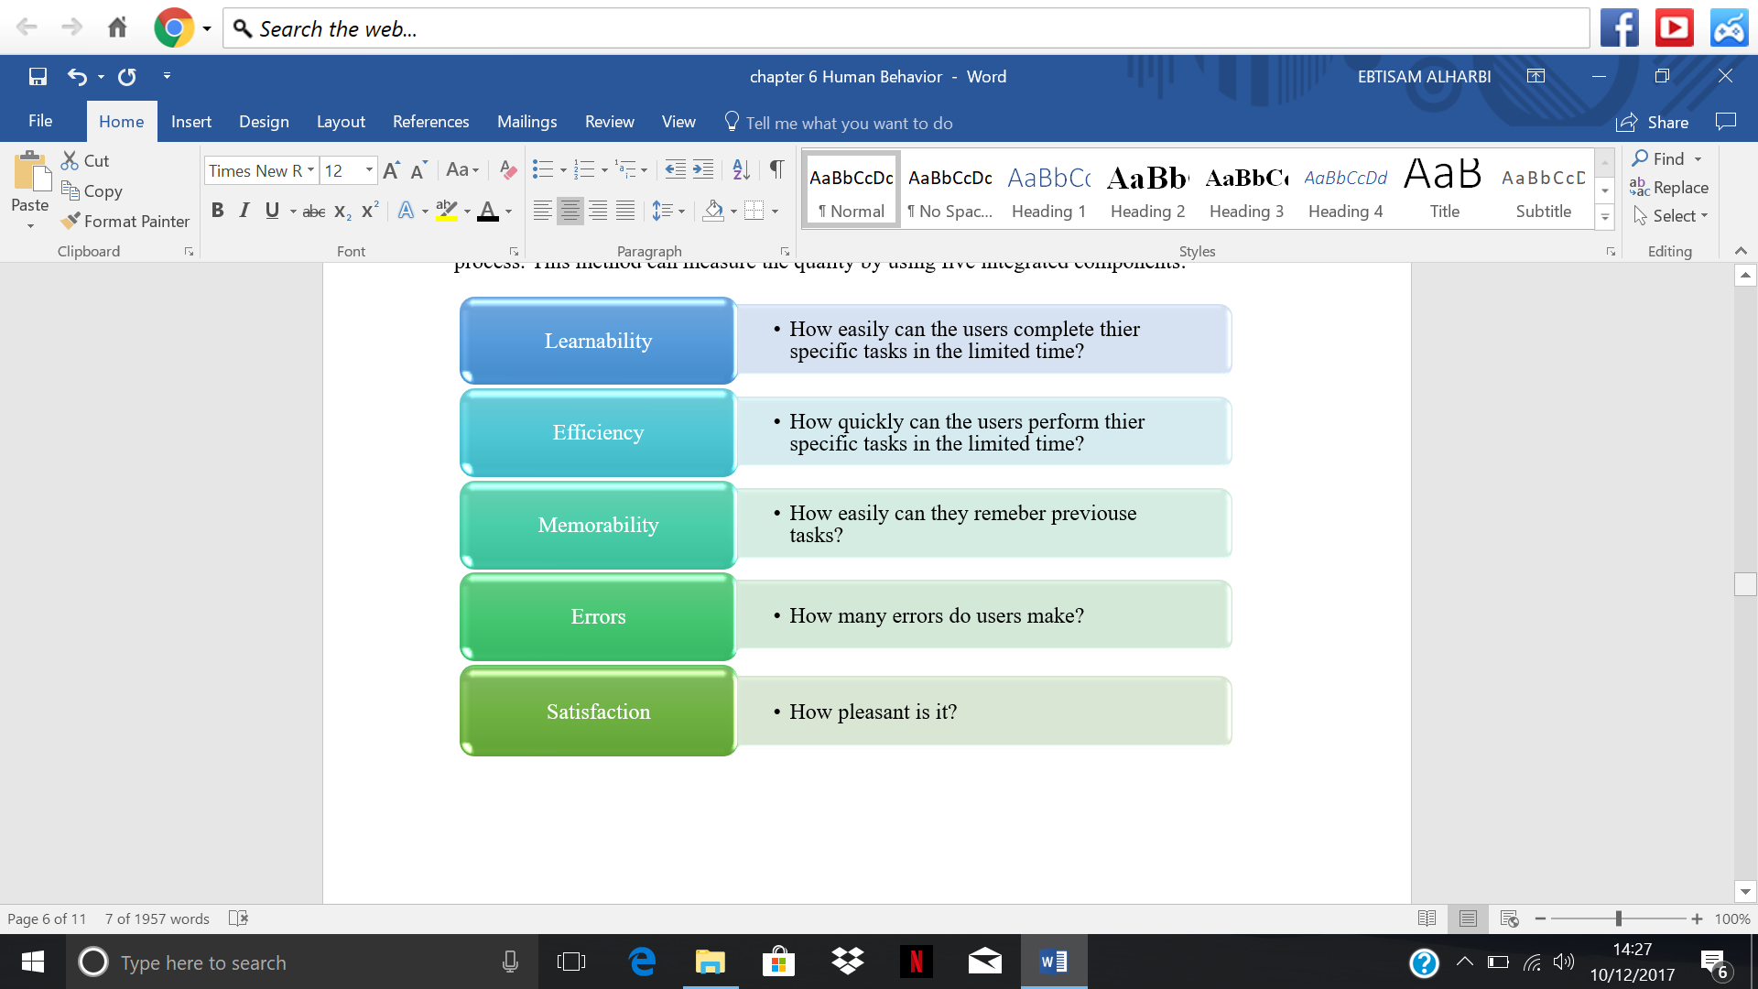

Figure 22 The components of usability

**6.3.2 Testing users**

Currently, the best practices spend about 10% of a design project's budget on usability (Hom, 2012). In Border Master, this quality attribute is an essential condition in the design phase to make sure the system meets the user needs easily to enhance the productivity. To study this usability in the project, user testing is the most powerful method Human Resource Department should run this test regularly, figure 23 below illustrates the procure of the test.

Figure 23 The usability test

After finishing this test, Human Resource Management Director, User Experience Manager should provide the report of the test to enhance the interfaces. Table 16 below presents the test’s result.

|  |  |  |  |  |  |  |  |  |  |
| --- | --- | --- | --- | --- | --- | --- | --- | --- | --- |
| Participant | Task1 | | Task2 | | Task3 | | Task4 | | |
| Supplier | Find FAQ | Time | Access the delivery state | Time | Return orders | Time | Cancel orders | Time | |
| 1 | √ | 7Sec | √ | 40Sec | × | 60Sec | √ | | 54Sec |
| 2 | √ | 20Sec | × | 60Sec | √ | 50Sec | × | | 60Sec |
| 3 | × | 60Sec | √ | 55Sec | √ | 39Sec | √ | | 57Sec |
| 4 | √ | 4 Sec | √ | 37Sec | × | 60Sec | × | | 60Sec |
| 5 | √ | 15 Sec | √ | 29Sec | √ | 43Sec | √ | | 49Sec |
| 6 | × | 60Sec | √ | 35Sec | √ | 46Sec | × | | 60Sec |
| 7 | √ | 5 Sec | √ | 44Sec | × | 60Sec | × | | 60Sec |
| 8 | √ | 30Sec | √ | 52Sec | √ | 33Sec | √ | | 55Sec |
| Completion rate | 6% | | 7% | | 5% | | 4% | | |
| Error | 2% | | 3% | | 5% | | 6% | | |
| Satisfaction | 8% | | 7% | | 6% | | 4% | | |

Table 16 The testing result

In conclusion, to enhance the usability of cybersecurity interfaces in Border Master, we must consider many aspects as following:

* Anticipate human behaviour vulnerabilities and check their risks.
* Increase users’ satisfaction through reducing confusion.
* Reducing workload.
* Reducing the impact of human errors
* Find bugs which may be caused by programmers or earlier implementation work.
* Provide evidence and information of the performance of the system in testing.
* To prevent defects to our system, database and our users, for example, hackers who are attacking the system to get user information will be concerned.
* To make a clear test plan of human behaviour and how to measure it.
* The earlier we are aware of the risks caused by human, the less will cost to mitigate them.

**Conclusion**

This project was undertaken to build the information security system for Border Master and apply the six principles of IT Governance. This study has identified these principles which are responsibility, strategy, Acquisition, performance, conformance and human behaviour to achieve the business’ objectives. The evidence from this study suggests that the relationship between these principles is not a linier, but they complete each other to improve the overall performance. These findings enhance our understanding of the importance of these principles in cyber security space. One source of weakness in this study which could have affected the project was the time which was limited. It is suggested that the association of these factors is investigated in future studies such as designing of architectures and implementations.

**References**

1. *GOV.UK. (2017). Data protection. Available at:* <https://www.gov.uk/data-protection>*, (Accessed: 06 December 2017).*
2. *Alan and Steve. (2015). IT Governance: An International Guide to Data Security and ISO27001/ISO27002, Kogan Page; 6 editions.*
3. *Humphreys, E. (2007). Implementing the ISO/IEC 27001 information security management system standard, Artech House, Inc.*
4. *DSS, P. (2010). PCI DSS quick reference guide. Retrieved on April 19, p.2011.*
5. *(n.d.). Retrieved from https://reqtest.com/requirements-blog/functional-vs-non-functional-requirements/*
6. *9241-210:2010, I. (n.d.). ISO 9241-210:2010.*
7. *A Guide to the Project Management Body of Knowledge (4th edition ed.). (n.d.).*
8. *Alertbox, k. N. (2003). Nielsen Norman Group . Retrieved from https://www.nngroup.com/articles/usability-101-introduction-to-usability/*
9. *Alwan, M. (2015, 01 09). What is System Development Life Cycle? Retrieved 12 3, 2017, from airbrake: https://airbrake.io/blog/sdlc/what-is-system-development-life-cycle*
10. *Ellram. (1993). Total Cost of Ownership: Elements and Implementation[J]. Journal of Supply Chain Management, 2-11.*
11. *functional-vs-non-functional-requirements. (2012). Retrieved from https://reqtest.com/requirements-blog/functional-vs-non-functional-requirements/*
12. *Garvey. (2008). Analytical Methods for Risk Management: A Systems Engineering Perspective. Taylor & Francis Group (UK), Boca Raton, London, New York.*
13. *HACHERO, R. (2014, 10 4). Contract Change Management: Process . Retrieved 11 2017, from https://www.linkedin.com/pulse/20141004044702-136793291-contract-change-management-process*
14. *Hom, J. (2012). Usability test tutorial. Retrieved from http://usability.jameshom.com*
15. *investinganswers. (2003). Retrieved from http://www.investinganswers.com/financial-dictionary/businesses-corporations/operating-cost-6793*
16. *ISO31000. (2009, 11 13). International Organization for Standardization.*
17. *Michael W. Boyce1, K. M. (2011). Human Performance in Cybersecurity . SAGE, 115-119.*
18. *Michael W. Boyce1, K. M.-R. (2011). Human Performance in Cybersecurity . 1115-1119 .*
19. *MITRE. (n.d.). Risk Mitigation Planning, Implementation, and Progress Monitoring . Retrieved 11 22, 2017, from Systems Engineering Guide: https://www.mitre.org/publications/systems-engineering-guide/acquisition-systems-engineering/risk-management/risk-mitigation-planning-implementation-and-progress-monitoring*
20. *Papamichail, N. (2009). Decision behavior analysis and support (Vol. 13). Simon French.*
21. *Poppe, S. (2016, 3 5). What a Risk Decision Actually Is. Retrieved 11 22, 2017, from https://www.linkedin.com/pulse/what-risk-decision-actually-steve-poppe*
22. *Professional academy. (n.d.). MARKETING THEORIES – PESTEL ANALYSIS. Retrieved 11 21, 2017, from https://www.professionalacademy.com/blogs-and-advice/marketing-theories---pestel-analysis*
23. *Sean. (n.d.). How to Be Luckier: The Black Swan Effect. Retrieved 11 20, 2017, from https://thegrowthlist.com/how-to-be-luckier-black-swan/*
24. *SlideShare. (2009, 03 24). Information Systems Life Cycle. Retrieved 12 05, 2017, from SlideShare: https://www.slideshare.net/4goggas/information-systems-life-cycle*
25. *Thalesgroup. (2015). Thalesgroup. Retrieved from https://www.thalesgroup.com/sites/default/files/asset/document/preplondonforchangeawv1_0.pdf*
26. *Transformance Advisors. (2017). 5 Steps to Successful Supplier Selection. Retrieved 11 26, 2017, from http://transformanceadvisors.com/portfolio-view/successful-supplier-selection/*
27. *performance testing of web server. (2013, 07 19). Retrieved 12 06, 2017, from webjx: http://www.webjx.com/program/zonghe-33845.html*
28. *how to defend DDOS. (2015, 09 18). Retrieved 12 06, 2017, from zhuanlan: https://zhuanlan.zhihu.com/p/22953451*
29. *how to inject SQL. (2015, 08 27). Retrieved 12 06, 2017, from bobao: http://bobao.360.cn/learning/detail/617.html*
30. *principle of SQL injection. (2015, 07 31). Retrieved 12 06, 2017, from CSDN: http://blog.csdn.net/wujunokay/article/details/47168701*
31. *what is concurrency. (2015, 10 19). Retrieved 12 06, 2017, from zhihu: https://www.zhihu.com/question/36609725*
32. *flow production tool trafgen. (2017, 01 11). Retrieved 12 06, 2017, from codeshold: http://codeshold.me/2017/01/trafgen_intro.html*
33. *how to improve concurrency. (2017, 04 29). Retrieved 12 06, 2017, from baidu: https://zhidao.baidu.com/question/522252546140453325.html*
34. *How to test SQL injection. (2017, 08 08). Retrieved 12 06, 2017, from webo: https://www.weibo.com/ttarticle/p/show?id=2309404138533584537223*
35. *Web Testing Knowledge. (2017, 08 01). Retrieved 12 06, 2017, from CSDN: http://blog.csdn.net/u010574553/article/details/76559594*
36. *baidu. (n.d.). DDOS. Retrieved 12 06, 2017, from baidu: https://baike.baidu.com/item/%E5%88%86%E5%B8%83%E5%BC%8F%E6%8B%92%E7%BB%9D%E6%9C%8D%E5%8A%A1%E6%94%BB%E5%87%BB/3802159?fr=aladdin&fromid=444572&fromtitle=DDOS*
37. *Liang, C. (2015, 10 21). concurrency and throughtput in performance testing. Retrieved 12 05, 2017, from zhihu: https://www.zhihu.com/question/36734171*
38. *NewFounder. (2014, 05 28). 2/5/10 principle in response time. Retrieved 12 05, 2017, from 51testing: http://www.51testing.com/html/75/534775-862195.html*
39. *SQL injection. (n.d.). Retrieved 12 06, 2017, from Wekipedia: https://en.wikipedia.org/wiki/SQL_injection*
40. *think2me. (2014, 08 12). what is session. Retrieved 12 06, 2017, from http://blog.csdn.net/think2me/article/details/38726429*
41. *Joyce Hill.Capacity Requirement Planning[Z].:2-5.*
42. *Zhidong Zhang.Research on MRP / CRP System Based on C / S Structure[D].Shandong Normal University,1999:26-34*
43. *Isaca. COBIT 5: Enabling Processes. ISA, 2012.*
44. *Ridley, G., J. Young, and P. Carroll. "COBIT and its utilization: a framework from the*
45. *literature." Hawaii International Conference on System Sciences IEEE, 2004:80233.*
46. *ISACA. "COBIT 5 : A BUSINESS FRAMEWORK FOR THE GOVERNANCE AND*
47. *MANAGEMENT OF ENTERPRISE IT." (2012).*
48. *Hardy, Gary. "Using IT governance and COBIT to deliver value with IT and respond to*
49. *legal, regulatory and compliance challenges." Information Security Technical Report*
50. *11.1(2006):55-61.*
51. *Spremic, M, Z. Zmirak, and K. Kraljevic. "IT and business process performance*
52. *management: Case study of ITIL implementation in finance service industry."*
53. *International Conference on Information Technology Interfaces IEEE, 2008:243-250.*